Class 1 Cycle A- A1
Subject: History Unit: Christmas within living memory
 | Week 1 | Week 2 | Week 3 | Week 4 | Week 5 | Week 6
National Curriculum (by the end of KS1) | - Pupils should develop an awareness of the past, using common words and phrases relating to the passing of time.  - They should know where the people and events they study fit within a chronological framework and identify similarities and differences between ways of life in different periods.  - They should use a wide vocabulary of everyday historical terms.  - They should ask and answer questions, choosing and using parts of stories and other sources to show that they know and understand key features of events.  - They should understand some of the ways in which we find out about the past and identify different ways in which it is represented
Year 1 Milestone | - Pupils begin to develop an awareness of the past, using common words and phrases relating to the passing of time.  - They should know where some people and events fit within a chronological framework and identify some similarities and differences between ways of life.  - They should explore the use of vocabulary for everyday historical terms.  - They should ask and answer questions, relating to stories and other sources to gain some understanding of key features of events.  - They show an understanding of some of the ways in which we find out about the past and how it is represented.
Learning Objective | To understand the concept of living memory. | To identify changes in recent Christmas traditions. | To explore how Christmas decorations have evolved. | To investigate the role of media in shaping Christmas. | To examine changes in Christmas foods. | To reflect on personal history (and create a class Christmas memory book).
Revisit and review | Tell me what history is in three words. | What is living memory? Tell me three events from your life. | Show me a Christmas tradition using actions/ decisions. | Name three materials that decorations have been made from over the years. | How does *this advert make you feel?  *select a popular Christmas advert to share. | Tell me a food you enjoy at Christmas time. Could this have been eaten by my mum aged 6 in 1969?
Key skills- how to achieve the LO  (substantive knowledge) | Living memory  Knowledge of what living memory comprises, specifically within the context of personal experiences and recent historical events.  Personal memories to model with the children:  Born, sibling entering family, special holidays, starting school, university, having children, getting a pet, getting married etc. | Christmas traditions  To recognise basic historical concepts of change and continuity in a familiar context.  Traditions to explore – trees, decorations, cards, advent calendars, adverts, pantomines, mistletoe, jumpers, stockings, jumpers, crackers, carol singing  Explore: Why do you think this is a change?  What makes this a tradition? | Christmas decorations  Traditional decorations (e.g., holly, candles).  The introduction of glass ornaments in the 19th century.  Modern-day decorations (e.g., electric lights, inflatable decorations) | Role of media in cultural celebrations  Watch a short clip from The Gruffalo’s Child or The Snowman and ask - What happened in the video? How did it make you feel? What do you think about Christmas after watching that?  Explore: A study on the John Lewis adverts through the years.  https://www.johnlewis.com/content/gifts/every-john-lewis-christmas-advert-ever-aired  What is the story that each advert is telling? Children to summarise this in groups. | Christmas foods  Knowledge of various Christmas foods historically and in modern times.  Which foods do you think are most popular in our time? Why?  What are some foods that have been around for a long time?  How do you think people prepared them? | Personal and community history  How did your family celebrate Christmas last year?  What is one special memory you have with your family during Christmas?  How do you feel when you think about Christmas? What makes you happy?
Key skills- how to achieve the LO  (disciplinary knowledge) | Create a personal memory timeline.  Understanding historical time periods.  Understanding living memory’s importance in connecting people to past events, and how personal experiences shape collective memory. | Christmas traditions – changes and continuities sorting task  Analysing continuity and change in the context of Christmas.  Students should understand that Christmas is celebrated differently across cultures and families, that some traditions are ancient while others are modern, and how societal changes influence celebrations. | Explore evolution of decorations timeline and then make own decoration.  Understanding historical evidence in the context of Christmas decorations- how do we know about decorations from the past? Explore photographs, artefacts and first-hand accounts.  The significance of Christmas decorations in various cultures.  How materials and styles of decorations have changed over time. | Create a Christmas media collage in groups- relates these to a different John Lewis advert through the years.  Evaluating sources in the context of exploring Christmas through the media.  The role of various media forms (like television shows, advertisements, and books) in shaping their experiences and perceptions of Christmas.  That media can influence emotions, beliefs, and festivities associated with Christmas through storytelling and imagery. | Foods from the past and foods today sorting task. Create a group ‘Christmas Food Time Capsule’.  Awareness of changes in food availability and preparation methods due to technological advancements and cultural influences.  Understanding how to compare and contrast historical and contemporary practices.  Recognising the impact of culture and time on food traditions. | Create a Christmas memory page to be collated into a shared book.  Reflection and interpretation. Students will develop historical awareness by understanding how their personal histories are part of broader cultural traditions.  They will learn about the importance of shared memories and how they can express and document their personal celebrations in a creative format.
Key vocabulary | Memory: The mental capacity to remember things.  Living Memory: Events and experiences that people can remember from their own lives or from their immediate family.  History: The study of past events, especially in human affairs.  Timeline: A graphic representation of the passage of time as a line. | Tradition: A custom or belief handed down from generation to generation.  Change: Something that has become different from what it was before.  Continuity: The existence of something over a period of time without change.  Celebrate: To mark a special event or occasion with activities or festivities. | Decoration: An item that is used to make something look more attractive, especially during festivals.  Tradition: A long-established custom or belief that has been passed down through generations.  Evolution: The gradual development of something, especially from a simple to a more complex form. | Media: Different ways we share information, such as TV shows, books, and advertisements.  Christmas: A holiday celebrated on 25th December to remember the birth of Jesus.  Collage: A piece of art created by sticking different materials, like photographs and pieces of paper, onto a surface. | Tradition: A custom or belief that has been passed down from generation to generation.  Era: A period in history marked by notable events or characteristics.  Cuisine: A style of cooking, especially as characteristic of a particular country or region.  Ingredients: The individual food items that are combined to create a dish. | Memory: Something that you remember from the past.  Tradition: A way of doing something that is special to a group of people.  Celebration: A special event to mark something meaningful.

In the event of a 7-week term- use the final week for post unit assessment of topic and pre-learning for upcoming term

Class 1 Cycle B - Spr 1
Subject: History Unit: Significant Explorers
 | Week 1 | Week 2 | Week 3 | Week 4 | Week 5 | Week 6
Year 3 Milestone | - Pupils should develop a chronologically secure knowledge and understanding of British, local and world history.  - They should begin to identify contrasts over time and develop the appropriate use of historical terms.  - They should begin to address historically valid questions about change, cause, similarity and difference.  - They should begin to construct informed responses that involve selection of relevant historical information.  - They should begin to understand how our knowledge of the past is constructed, exploring what sources are.
National Curriculum (by the end of KS1) | - Pupils should develop an awareness of the past, using common words and phrases relating to the passing of time.  - They should know where the people and events they study fit within a chronological framework and identify similarities and differences between ways of life in different periods.  - They should use a wide vocabulary of everyday historical terms.  - They should ask and answer questions, choosing and using parts of stories and other sources to show that they know and understand key features of events.  - They should understand some of the ways in which we find out about the past and identify different ways in which it is represented
Year 1 Milestone | - Pupils begin to develop an awareness of the past, using common words and phrases relating to the passing of time.  - They should know where some people and events fit within a chronological framework and identify some similarities and differences between ways of life.  - They should explore the use of vocabulary for everyday historical terms.  - They should ask and answer questions, relating to stories and other sources to gain some understanding of key features of events.  - They show an understanding of some of the ways in which we find out about the past and how it is represented.
Learning Objective | LO. To know what an explorer is. | LO. To recognise the achievements of different explorers using photographs. | LO. To record events on a timeline. | LO. To use photographs to find out about the past. | LO. To discuss, explore and reflect on the achievements of an explorer. | LO. To develop an understanding of primary sources.
Revisit and review | How long ago is living memory?  How can we find out about the past within living memory? | Can you remember the names of any important explorers?  What is an explorer? | How did people travel in the past? | Where did Christopher Columbus travel to?  Was Christopher Columbus’ voyage good or bad for the people living in the Americas? | Tell your partner three things about Matthew Henson. | Tell me three things about Matthew Henson.  Tell me something about Neil Armstrong.  Who was Christopher Columbus?
Key skills- how to achieve the LO  (substantive knowledge) | Explorers go on long journeys to lots of different places. They usually explore places that are challenging to get to and some explorers make discoveries (meaning they find new things). They need to take items to help them explore and this is called their equipment.  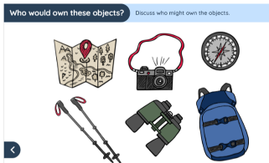 | What did Dame Ellen MacArthur achieve? (She set a world record for the fastest solo non-stop voyage around the world on her first attempt in 2005.)  What did Matthew Henson achieve? (Matthew Henson and explorer Robert Peary said they were the first men to reach the North Pole in 1909.)  What did Mary Kingsley achieve? (She travelled to Africa, climbed Mount Cameroon and learnt about new animals in 1893.)  What did Christopher Columbus achieve? (At the time, people thought Christopher Columbus was a great man for discovering The Americas in 1492 – this was somewhere new to people from Europe.) | Christopher Columbus  First voyage over 500 years ago in 1492.  Satellites take photographs of the Earth. In the past, maps were created by explorers, who sailed around the world discovering new land.  Where did Christopher Columbus want to go? (‘The Indies’ – China and India.)  Who helped him to get there? (King Ferdinand II of Spain.)  How did he get there? (By sailing ship.)  Where did he land? (‘The Americas’ – we now know as the Bahamas in North America.) | Matthew Henson  Matthew Henson and explorer Robert Peary said they were the first men to reach the North Pole in 1909.  The North Pole is in the Arctic.  Henson went to the Arctic seven times with fellow explorer Robert E Peary between 1891 and 1909.  After reaching the North Pole in 1909, Peary, the leader of the expedition returned to the US as a hero. At the time, the USA was very racially divided. Black people faced discrimination, and as an African-American man, Henson received little of the attention or appreciation that Peary did. It wasn't until nearly thirty years later, in 1937 that Matthew Henson began to be recognised for his achievement. | Neil Armstrong  Neil Armstrong is famous for being the first human to walk on the Moon.  He was a space explorer.  In 1969, Neil Armstrong was the commander of the Apollo 11 mission.  Two other astronauts, Buzz Aldrin and Michael Collins, were aboard the spacecraft with him.  They launched from Kennedy Space Centre on 16th July 1969.  Neil would always point to all the great work done by the large team that he was part of. That team who he worked with allowed him to take that first step on the Moon. | Amelia Earhart  What did Amelia Earhart achieve? (She was the first woman to fly solo across the Atlantic Ocean and the first person to fly solo across the Pacific Ocean.)  A source is an item that provides historians with information about the past.  Primary source – original item from the period being studied that has not been changed in any way.  Is an eyewitness account a primary source? (Yes because it is from someone who was at the event being studied.)
Key skills- how to achieve the LO  (disciplinary knowledge) | Equipment has changed for explorers over the years as technology has developed. | Photographs add depth to our historical enquiry as we can compare how voyages have been made over the years.  No photographs available for Christopher Columbus and his voyages as 1839 was the birth year of practical photography. | Timelines support our understanding of events. Ordering a historical story chronologically enables us to relive the lives of explorers beyond living memory. | Photographs add depth to our historical enquiry as we can understand the voyage across the Arctic – before, during and after. | Television has developed our understanding of historical events. We can appreciate what it was like for explorers during the time being studied. | Eyewitnesses have helped historians develop their understanding on events from first-hand experiences.  Discussions around validity can support our viewpoint on this primary source.
Key vocabulary | beyond living memory  discovery  equipment  exploration  explorer  living memory  past  present | achievement  within living memory  beyond living memory  discovery  explorer  living memory  solo  timeline  transport | achievement  voyage  explorer  beyond living memory  timeline | achievement  explorer  timeline  beyond living memory  North Pole  voyage | commemorate  explorer  exploration  significant  space  timeline  voyage | beyond living memory  present  primary source  eyewitness account  past  source  evidence  achievement

Class 1 Cycle B- Sp2
Subject: History Unit: Great fire of London
 | Week 1 | Week 2 | Week 3 | Week 4 | Week 5 | Week 6
Year 3 Milestone | - Pupils should develop a chronologically secure knowledge and understanding of British, local and world history.  - They should begin to identify contrasts over time and develop the appropriate use of historical terms.  - They should begin to address historically valid questions about change, cause, similarity and difference.  - They should begin to construct informed responses that involve selection of relevant historical information.  - They should begin to understand how our knowledge of the past is constructed, exploring what sources are.
National Curriculum (by the end of KS1) | - Pupils should develop an awareness of the past, using common words and phrases relating to the passing of time.  - They should know where the people and events they study fit within a chronological framework and identify similarities and differences between ways of life in different periods.  - They should use a wide vocabulary of everyday historical terms.  - They should ask and answer questions, choosing and using parts of stories and other sources to show that they know and understand key features of events.  - They should understand some of the ways in which we find out about the past and identify different ways in which it is represented
Year 1 Milestone | - Pupils begin to develop an awareness of the past, using common words and phrases relating to the passing of time.  - They should know where some people and events fit within a chronological framework and identify some similarities and differences between ways of life.  - They should explore the use of vocabulary for everyday historical terms.  - They should ask and answer questions, relating to stories and other sources to gain some understanding of key features of events.  - They show an understanding of some of the ways in which we find out about the past and how it is represented.
Learning Objective | To compare past and present London. | To explain how people live now is different to how people lived in 1666. | To order the events of the Great Fire of London. |  |  | To describe London before, during and after the Great Fire.
  To explain how we know about the Great Fire of London.
  To explain how London changed after the Great Fire.
Revisit and review | What is beyond living memory? How can we find out about the past beyond living memory? | What was life in London like in 1666?  *Buildings focus | Name three occupations from 1666. | When did the fire start? | What do we know about what London was like before the fire started in 1666? | Who was the architect that King Charles II appointed?
Key skills- how to achieve the LO  (substantive knowledge) | London is the capital city of the UK.  Present day photographs help us explore what the city looks like.  London in the past- the year 1666 was in the 17th century. Illustrations to support understanding of what life was like.  Buildings focus - Houses were often made from wood and had straw roofs. They were not made of bricks as they often are today.  Samuel Pepys (1633 – 1703). He was a Member of Parliament and lived in London. He kept a very detailed diary from 1660  to 1669 and this diary became one of the most important sources of information about London during this time in history. | The Great Fire of London is an event that happened beyond living memory that is important to the United Kingdom (England).  In 1666 – life was very different in London. Occupations allow us to compare past and present day.  Firefighter focus- There was no organised fire brigade in 1666. Firefighting was very basic and people did not learn much about how to do it.  Leather buckets full of water were thrown onto fire to put it out. Water squirts were also used. This water had to be carried from wells or from the river because there were no taps in houses. | The Great Fire of London happened between 2-5 September in 1666. The fire began in a bakery in Pudding Lane.  Before the fire began, there had been a drought in London that lasted for 10 months, so the city was very dry.  In 1666, lots of people had houses made from wood and straw, which burned easily. To fight fires during this time, people would have used leather buckets, metal hooks and water squirts. All of these factors contributed to spreading the fire and making it such a devastating event.  London was very dry after a long, hot summer.  The streets were very narrow.  Houses were made of wood and straw.  There was a very strong wind that blew the fire from house to house.  There were lots of warehouses near the bakery that were full of things like wood and rope, which caught fire easily. | People could write  things down in 1666.  Some people had quills,  sheets of paper and notebooks.  Quills were writing tools that were used before pens were invented. They were made by sharpening the tip of a feather and were dipped in ink to write with.  Excerpt to focus on from Samuel Pepys’ Diary- ‘Jane called us up about three in the morning, to tell us of a great fire they saw in the City. So I rose and slipped on my nightgown, and went to her window, …I thought it far enough off; and so went to bed again and to sleep…By and by Jane comes and tells me that she hears that above 300 houses have been burned down to-night by the fire we saw, and that it is now burning down all Fish-street, by London Bridge.’ | In October 1666, King Charles appointed architects, including Sir Christopher Wren, to plan how to rebuild London.  Lots of the work was completed by 1676 (ten years after the fire).  Some streets were made wider or straighter. Wider streets help to space out houses for safety and allow people and transport to move around more easily.  Houses began to be made mainly of brick, though some use of wood was allowed. The grander houses sometimes had doorways and windows made out of stone. Brick and stone are not flammable materials (they cannot catch fire easily like wood can).  Water pipes that were destroyed during the fire were rebuilt so it was easier to send water from the river Thames to the houses close by.  However, pipes were still made of wood for  many years. Water pipes in London today are mostly made of cast iron. | Before the fire- Many houses were made from wood with straw roofs. Streets were very narrow and not straight. This meant that they could become very crowded. Houses were very close together. Many tall buildings also had upper floors that ‘jutted’ out into the street.  During the fire- The fire started on Sunday 2nd September 1666 in a baker’s shop owned by Thomas Farriner.  The fire spread through London. People tried to put it out.  People had to carry their belongings to safety using boats on the river Thames.  By Thursday, the wind had died down and many buildings had been pulled down so the fire had stopped.  After the fire- At least 65,000 people were left homeless. Many lived in tents in fields outside of London. Around a third of the city needed to be rebuilt.
  1666 jobs- chimney sweep, blacksmith, apothecary, rat-catcher, gong farmer, spinner, chandler, cook, scullery maid, carpenter, musician, firefighter.
Key skills- how to achieve the LO  (disciplinary knowledge) | Photographs add depth to our historical enquiry as we can compare London past and present.  No photographs available for London in 1666 as 1839 was the birth year of practical photography. | Equipment has changed over the years as technology/ materials have developed.  Occupations have changed over time to suit the needs of our nation. | Timelines support our understanding of events. Ordering a historical story chronologically enables us to relive the events of an important UK event beyond living memory.  Diaries are a primary source. Samuel Pepys documented the fire. | Photographs vs paintings- paintings of the fire, while helpful for showing us what it would have looked like, were often produced much later.  Samuel Pepys was an eyewitness to the fire- diaries can be useful sources of information about the past. | The details of King Charles II speech were written down in this declaration from 1666. This is an important historical source to give us an idea of what happened after the fire.  Over time, the safety and durability of buildings has improved due to what people learn from events that happen. The GFoL is an example of this. | We know about the Great Fire of London because of historical sources.  For example: London Gazette newspaper report from  3rd September 1666, an eyewitness statement  about the fire, signed by  John Morgan in 1668 and Samuel Pepys' diary entries from 2nd - 6th September 1666.
Key vocab: | Beyond living memory  17th century  London  Past  Present  Photographs  Illustrations  Compare  Contrast | 17th Century - From the year 1601 to 1700. The Great Fire of London happened in the 17th century, in 1666.  Diary- A book that people write about their lives in.  Rebuilt- Building something again after it’s been broken or destroyed.  St Paul’s Cathedral - A very large church in London. St Paul’s Cathedral was rebuilt after the fire.  Timeline- A timeline is a way of visually sequencing events in chronological order. | Century  London  Order  Event  Timeline  Change | Source  Reliable  Information  Eyewitness  Diary  Samuel Pepys | Rebuild  King Charles II  Sir Christopher Wren  St Paul’s Cathedral  The Monument  Architect  Declaration  Flammable  Architect: A person whose job is to design buildings and plan how they will be built. | Before During After Change  Century  King Charles II  Sir Christopher Wren  Samuel Pepys  Architect  Declaration  Historical source

Class 1 Cycle B- Su2
Subject: History Unit: Significant individuals
 | Week 1 | Week 2 | Week 3 | Week 4 | Week 5 | Week 6
Year 3 Milestone | - Pupils should develop a chronologically secure knowledge and understanding of British, local and world history.  - They should begin to identify contrasts over time and develop the appropriate use of historical terms.  - They should begin to address historically valid questions about change, cause, similarity and difference.  - They should begin to construct informed responses that involve selection of relevant historical information.  - They should begin to understand how our knowledge of the past is constructed, exploring what sources are.
National Curriculum (by the end of KS1) | - Pupils should develop an awareness of the past, using common words and phrases relating to the passing of time.  - They should know where the people and events they study fit within a chronological framework and identify similarities and differences between ways of life in different periods.  - They should use a wide vocabulary of everyday historical terms.  - They should ask and answer questions, choosing and using parts of stories and other sources to show that they know and understand key features of events.  - They should understand some of the ways in which we find out about the past and identify different ways in which it is represented
Year 1 Milestone | - Pupils begin to develop an awareness of the past, using common words and phrases relating to the passing of time.  - They should know where some people and events fit within a chronological framework and identify some similarities and differences between ways of life.  - They should explore the use of vocabulary for everyday historical terms.  - They should ask and answer questions, relating to stories and other sources to gain some understanding of key features of events.  - They show an understanding of some of the ways in which we find out about the past and how it is represented.
Learning Objective | To use photographs to find out about the past. | To explore and order the events around Rosa Parks’ bus boycott. | To include details when I talk or write about events, people and themes from the past.  Two lessons |  | Review lessons as they progress – put in a further lesson on primary sources here? | Reflections and assessment – write a fact file as end of unit task?
Revisit and review | What does significant mean? Which significant explorers can we recall? | 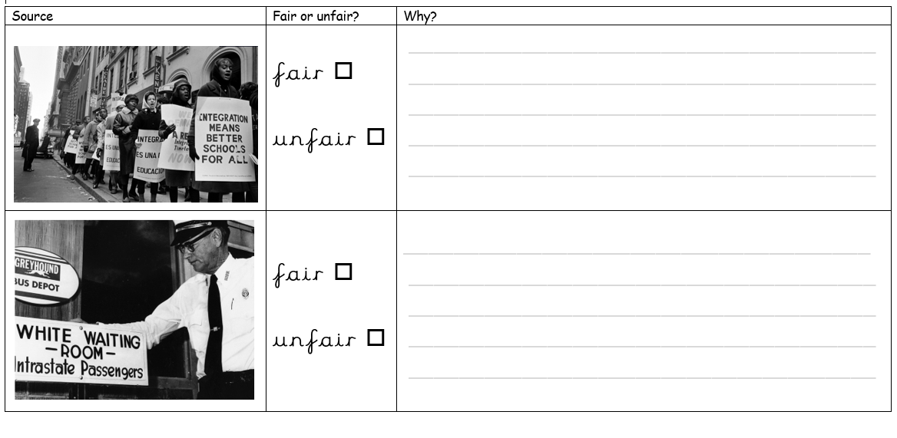 | Recall of fundamental knowledge from last lesson:  Who?  When?  Where?
Key skills- how to achieve the LO  (substantive knowledge) | Explore concept of fairness to the children – fair and unfair - what do you think these words mean?  Share primary sources – photographs –  Was this fair?  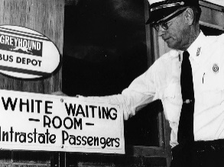  What is happening here?  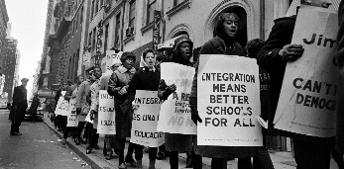  Was this fair?  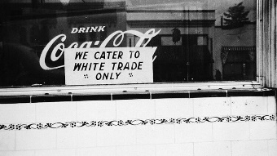  Was this fair?  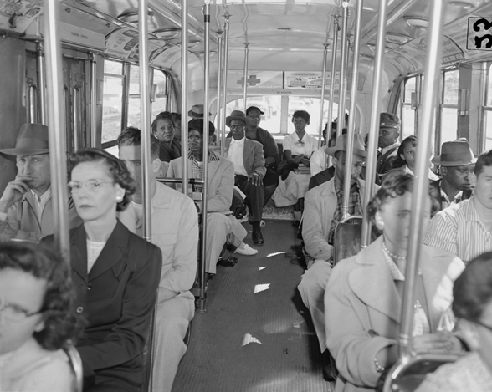 | Further explore the concept of segregation – watch this video to have a first-hand account. Search ‘msnbc segregation clip’ on YouTube.  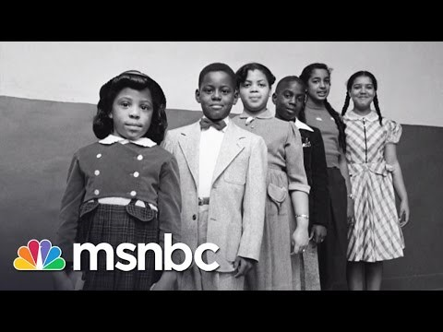  Read ‘Little People, Big Dreams- Rosa Parks’. Share the book focussing on early life with the focus on segregation – what life was like in America. Discuss.  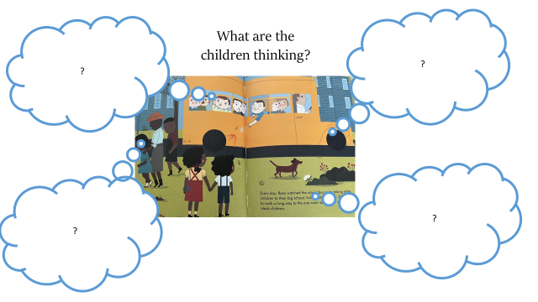  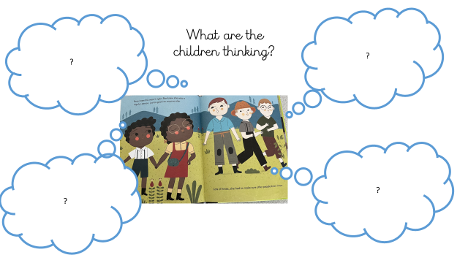  Fundamental knowledge-  Who – Rosa Parks  When – 1955  Where – Alabama, USA, North America  How - In 1950s America black people were treated unfairly. On December 1, 1955, Rosa Parks was tired of having to give up her bus seat and she said “No” to a white person. This resulted the in the ‘Bus boycott’ and eventually a rule change.  Read rest of book and Share video clip from BBC Bitesize.  https://www.bbc.co.uk/bitesize/articles/zkhknrd  Task – timeline of events. | What did Rosa parks do?  https://www.bbc.co.uk/teach/class-clips-video/articles/z7rtvk7  Line up the chairs to make a bus, playing out Rosa's refusal to move from her seat.  Children to model feelings and anxieties around how Rosa Parks is feeling.  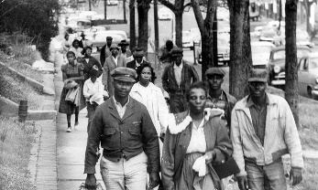  What happened after Rosa said ‘no’?  Role play the boycotts that followed.  Task idea - Make posters.  We want equal rights  Treat everyone fairly  Everyone matters  Stop segregation  All people are created equal  Then play out a protest. A protest is a gathering of people that share the views/beliefs and trying to be heard to inspire change.  Task idea – after role play, children write a short diary entry including details of what happened and how Rosa felt.
Key skills- how to achieve the LO  (disciplinary knowledge) | Chronology- Understanding that segregation happened in the past – place 1955 on a simple timeline in preparation for our next lesson.  Sources of evidence- looking at simple sources like photographs, stories or videos. | Cause and effect – exploring how Rosa Parks’ actions led to changes (eg. Bus boycotts, civil rights).  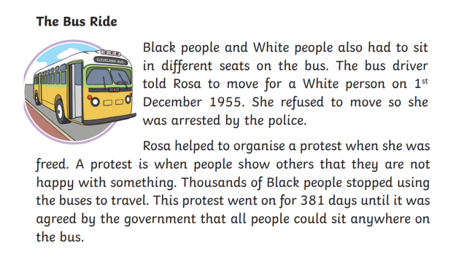  Sources of evidence- looking at simple sources like photographs, stories or videos. | Change and continuity- Noticing how life for Black and white people has changed since the time of segregation.  Similarity and difference- Comparing the lives of children today with those of children in 1955 in America.  Significance- understanding why Rosa Parks is remembered and celebrated.
Key vocab: | racism, activist, boycott, segregation, protest, rights, Black lives matter

