Cycle B- Summer 1- Once upon a time
Key Texts | Little red hen | Little red riding hood | The 3 little pigs | The 3 billy goats gruff | The Gingerbread man
Cultural capital
Communication and language | - Learn rhymes, poems and songs.  - Engage in non-fiction books.  - Listen to and talk about selected non- fiction to develop a deep familiarity with new knowledge and vocabulary.  - Retell the story, once they have developed a deep familiarity with the text, some as exact repetition and some in their own words.
Learning Intention | Talk through what we had to do to make bread. | To discuss the story of Little red riding hood and talk through what a different ending could be. | Story map the three little pigs as a class. | Make individual story maps to retell the story of the three billy goats gruff | Talk about how the story could be different.
Direct Teaching | Having made bread- use the pictures to talk through how we made the bread- what did we have to do at each stage?  Mix knead bake share | M- read through the story  T- use the pictures to retell the story  W- talk about the start middle and end  T- what could a different ending be? Draw a picture and then share with the class. | Draw a story map as a class to retell the story of the 3 little pigs.  Use a large piece of paper and draw out pictures to retell the story- get the children to go through the pictures and retell the story- what key words do we need? | Having sequenced the story as a class yesterday this week we will be drawing our own story maps.  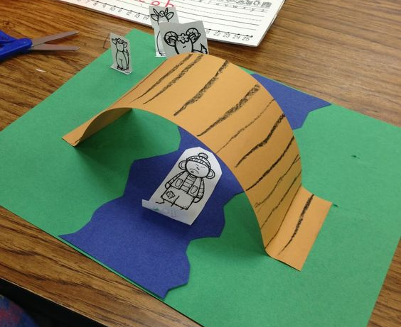  Once the story maps have been written, swap them over and tell the story using each others story maps.  Record for dojo/seesaw | C&L activity 1- reread the story- what would happen if TGBM swam across the river? Write childrens voice on post its  C&L activity 2- how could he get across the river?  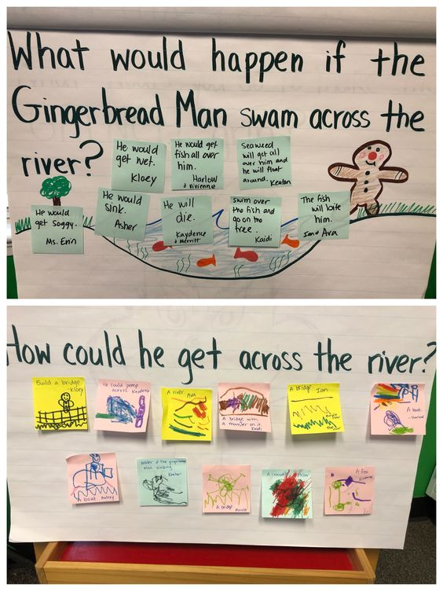
Adult-Led Provision  (enhancements and challenges) |  |  |  | cut out the characters to make a mini small world that can be used to retell the story.
Continuous Provision  (enhancements and challenges) | Flour water mixing bowls spoons etc to mix ‘bread’  Make different textures by adding more/less of an ingredient. | Small world forest- retell the story, ipads out to record each other telling the story. | Use the different construction resources to build a house for the three little pigs- will it be blown down by the big bad wolf? |  | Gingerbread scented playdough – rolling pins, gingerbread men cutters.
Key Vocab | Hen, Little, Farm, Wheat, Flour, Bake, Bread, Work, Help, Lazy, Task, Together, Grain, Eggs, Friend, Make, Hungry, Share, Proud, Refused | Little, Red, Hood, Forest, Grandmother, Basket, Woods, Path, Wolf, Danger, House, Grandmother’s house, Sick, Visit, Friend, Flower, Big, Trick, Pretend, Rescue | Pigs,House, Straw, Sticks, Bricks, Wolf, Blow, Strong, Weak, Big, Huff, Puff, Safe, Run, Wood, Build, Danger | Goats, Billy, Bridge, Troll, Mountain, Grass, River, Strong, Big, Small, Trip, Grow, Eat, Pass, Sly, Hungry, Dangerous, Run, Jump, Wait, Trick | Gingerbread, Man, Run, Bake, Oven, Cookies, Food, Jump, Chase, Fast, Little, Big, Laugh, Hungry, Fox, Stop, Safe, Trail, Hands, Catch, Escape
Personal, social and emotional development | - Think about the perspectives of others
 | SCARF- Being my Best | SCARF- Being my Best | SCARF- Being my Best | SCARF- Being my Best | SCARF- Being my Best | SCARF- Being my Best
Learning Intention
Direct Teaching
Adult-Led Provision
(enhancements and challenges)
Continuous Provision
(enhancements and challenges)
Key Vocab
Physical Development | - Progress towards a more fluent style of moving, with developing control and grace.  - Revise and refine the fundamental movement skills they have already acquired: Crawling, climbing.
Learning Intention | GS4PE- To copy and create shapes with your body. | GS4PE- To be able to create shapes whilst on apparatus. | GS4PE- To develop balancing and taking weight on different body parts. | GS4PE- To develop jumping and landing safely. | GS4PE- to develop rocking and rolling
Direct Teaching | DRFU  Get Set for PE- Gymnastics Unit 1- Lesson 1- To copy and create shapes with your body.  Theme: rainforest animals | DRFU  Get Set for PE- Gymnastics Unit 1- Lesson 2- To be able to create shapes whilst on apparatus.  Theme: woodland animals | DRFU  Get Set for PE- Gymnastics Unit 1- Lesson 3- To develop balancing and taking weight on different body parts.  Theme: lakeland animals | DRFU  Get Set for PE- Gymnastics Unit 1- Lesson 4- To develop jumping and landing safely.  Theme: desert animals | DRFU  Get Set for PE- Gymnastics Unit 1- Lesson 5- to develop rocking and rolling  Theme: sea animals
Adult-Led Provision
(enhancements and challenges)
Continuous Provision
(enhancements and challenges)
Key Vocab | Balance, bend, copy, hold, jump, land, rock, roll, shape, squeeze, star, still, straight | Balance, bend, copy, hold, jump, land, rock, roll, shape, squeeze, star, still, straight | Balance, bend, copy, hold, jump, land, rock, roll, shape, squeeze, star, still, straight | Balance, bend, copy, hold, jump, land, rock, roll, shape, squeeze, star, still, straight | Balance, bend, copy, hold, jump, land, rock, roll, shape, squeeze, star, still, straight
Literacy | - Write short sentences with words with known sound-letter correspondences using a capital letter and full stop.  - Re-read what they have written to check that it makes sense.  Little red hen | Little red riding hood | The 3 little pigs | The 3 billy goats gruff | The Gingerbread man
Learning Intention | Draw their favourite character from the story and write a sentence | Draw a map and write instructions on how Little Red Riding Hood would get to Granny’s house. | Draw a picture of the three little pigs house and writie what it is build from.  Draw another house- what else could the house be built from? | Write what happened after the troll fell into the river. | To write a caption showing what the Gingerbread Man would say.
Direct Teaching | Having read the story- talk about the different characters.  The hen, the Cat, the Dog, the Duck.  What were the characters doing whilst the hen was busy working?  Get the children to draw their favourite character from the story and write a sentence about what they were doing e.g. “The Little Red Hen is working hard”  “The dog is resting.”  Extend the sentence for HA by saying where the dog was resting e.g. “The dog was resting in the shed”.  Reminder of capital letter, finger spaces and full stop.  Say sentence- count words- repeat – write. Read sentence back to check. | Having read the story talk about what things were in the forest for Little Red to see and walk past on her way to Granny’s house.  Write instructions on how to get to Granny’s house, use - First Then Next (After that) like we did when writing about our pirate treasure maps.  Reminder of capital letter, finger spaces and full stop.  Say sentence- count words- repeat – write. Read sentence back to check. | Draw a picture of one of the three little pigs and their house.  Write sentence,  “The pigs house was made from…”  What else could the houses be built from?  Draw a picture and write a sentence  Challenge- Could the big bad wolf blow it down?  Write sentence.  “the big bad wolf huffed and puffed but did not blow it down”  Reminder of capital letter, finger spaces and full stop.  Say sentence- count words- repeat – write. Read sentence back to check. | share story- model and group write- after falling in the river the troll would…  “After falling in the river the troll would…”  Reminder of capital letter, finger spaces and full stop.  Say sentence- count words- repeat – write. Read sentence back to check. | Having read the story talk about what the GBMan says.  Have a speech bubble coming out of the GBMans mouth- what does he say?  Reminder of capital letter, finger spaces and full stop.  Say sentence- count words- repeat – write. Read sentence back to check.
Adult-Led Provision
(enhancements and challenges)
Continuous Provision
(enhancements and challenges)
Key Vocab | Hen, Little, Farm, Wheat, Flour, Bake, Bread, Work, Help, Lazy, Task, Together, Grain, Eggs, Friend, Make, Hungry, Share, Proud, Refused | Little, Red, Hood, Forest, Grandmother, Basket, Woods, Path, Wolf, Danger, House, Grandmother’s house, Sick, Visit, Friend, Flower, Big, Trick, Pretend, Rescue | Pigs,House, Straw, Sticks, Bricks, Wolf, Blow, Strong, Weak, Big, Huff, Puff, Safe, Run, Wood, Build, Danger | Goats, Billy, Bridge, Troll, Mountain, Grass, River, Strong, Big, Small, Trip, Grow, Eat, Pass, Sly, Hungry, Dangerous, Run, Jump, Wait, Trick | Gingerbread, Man, Run, Bake, Oven, Cookies, Food, Jump, Chase, Fast, Little, Big, Laugh, Hungry, Fox, Stop, Safe, Trail, Hands, Catch, Escape
Mathematics | - Explore the composition of numbers to 10  - Automatically recall number bonds for numbers 0–5 and some to 10.
Learning Intention | To 20 and beyond | To 20 and beyond | How many now? | Manipulate, compose and decompose | Manipulate, compose and decompose
Direct Teaching | Build numbers 10-13  Continue patterns beyond 10  Build numbers beyond 10 | Continue patterns beyond 10  Verbal counting beyond 20  Verbal counting patterns | Add more  How many did I add  Take away  How many did I take away | Select shapes for a purpose  Rotate shapes  Manipulate shapes  Explain shape arrangements | Compose shapes  Decompose shapes  Copy 2D shape pictures  Find 2D shapes within 3D shapes
Adult-Led Provision  (enhancements and challenges) | Building towers to 10, 11, 12 and 13 using construction equipment. Choose a number card and build a tower showing that many.  "How many blocks will you use to build your number?"  "Can you measure your building and tell me how tall it is?"  "What number card shows how many blocks you used?"
Continuous Provision  (enhancements and challenges) |  | Counting Station with Natural Objects  Using natural objects, small baskets and number cards.  Can the children put the correct amount of objects in the baskets? "How many ____ can you see in this basket?"  "Can you find the basket with ___pebbles? How do you know?"
Key Vocab | Number, ten, tens frame, how many?, total, eleven, twelve, thirteen, next, after, fourteen, fifteen, sixteen, seventeen, eighteen, nineteen, twenty | Number, Fourteen, Fifteen, Sixteen, Seventeen, Eighteen, Nineteen, Twenty, Count, Ten, Twenty, Thirty, Before, After, Count, Ten, Twenty, Thirty, Before, After | Add, More, How many?, Altogether, First, Then, Now, Take Away, Subtract, How many left? | 2-D Shapes. Square. Circle. Large. Small. Triangle. Rotate, complete, tangram, Rectangle Position Below Above Between | 2-D Shapes Square Triangle, rectangle, diagonal, rotate, 2-D 3-D Shapes Curved Sphere Cube Circular Surface Flat Faces Cylinder. Cuboid
Understanding the World | - Draw information from a simple map.  - Recognise some similarities and differences between life in this country and life in other countries. |  |  |  | EAD link
Learning Intention | To follow instructions to make bread. |  | To explore materials and their properties. | Investigate materials and construction. | To follow instructions to make a gingerbread man.
Direct Teaching | What did the little red hen need help making?  Watch clip  https://www.youtube.com/watch?v=1zUW6sqbM-U  today we will be following instructions to make bread, talk through the ingredients. Showing them as you go through- remember the flour is what the hen was harvesting.  Follow the instructions, taking pictures as you go.  I’ll ask Mrs Foster to cook them in her ovens. |  | Provide straw, sticks (twigs), and small bricks or blocks.  Let children try to build their own houses.  Use a hairdryer or fan as the “wolf” to see which houses stand.  Which material was best to build with?  Why do you think it was? | Provide materials (blocks, cardboard, sticks, string, Lego) and challenge children to build a bridge strong enough for toy goats to cross.  Test how many goats the bridge can hold. | Have you ever tried gingerbread before?  Today we will be following instructions to make gingerbread.  Talk through ingredients- showing them as you go.  Follow instructions- taking pictures as you go.
Adult-Led Provision
(enhancements and challenges)
Continuous Provision  (enhancements and challenges) | Flour water mixing bowls spoons etc to mix ‘bread’  Make different textures by adding more/less of an ingredient. |  |  | Fine motor-  Plastic cups and lolly pop sticks- create a bridge between the cups using the lolly pop sticks can the goats get over the river(draw river on table )
Key Vocab | Hen, Little, Farm, Wheat, Flour, Bake, Bread, Work, Help, Lazy, Task, Together, Grain, Eggs, Friend, Make, Hungry, Share, Proud, Refused
Expressive Art and Design | - Develop storylines in their pretend play  - Explore and engage in music making and dance, performing solo or in groups
Learning Intention | To use instruments to enhance the retelling of the story . | To experiment with instruments to create a musical journey. | To retell the story using sounds rather than words. | Collage trolls | To use technology to create a sound collage linked to the story.
Direct Teaching | Musical Storytelling with Instruments  Provide various instruments (e.g., shakers, drums, and xylophones). Read 'The Little Red Hen' aloud and encourage children to play their instruments at key moments in the story, such as when the hen finds the grains of wheat or when she bakes the bread. This activity supports creative expression and collaborative music making. | Musical Trail  Create an outdoor trail representing the path Little Red Riding Hood takes to her grandmother's house. Place music stations along the way, each featuring different instruments or music-related activities (e.g., clapping, singing). As children move from station to station, they can create their own musical journey. | Story Soundscape  Create a soundscape of the story using various musical instruments. Provide each child with an instrument (shakers, drums, xylophones) and ask them to represent different parts of the story – for example, the huffing and puffing of the wolf can be represented by blowing across the top of a bottle. | 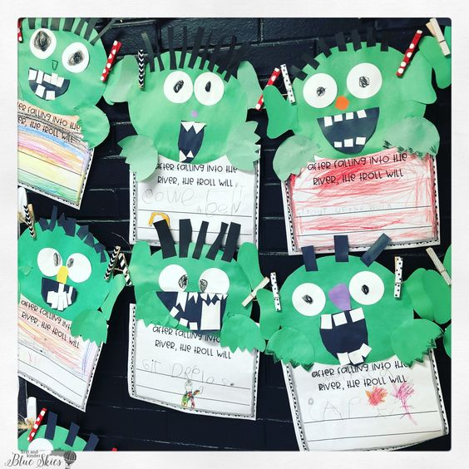 | Sound Collage Creation  Using a tablet or laptop, encourage children to create a sound collage using sound clips linked to the story—these could include animal sounds, cooking sounds, or nature sounds. This technology-based activity fosters creativity and sound exploration.
Adult-Led Provision  (enhancements and challenges) |  |  |  | 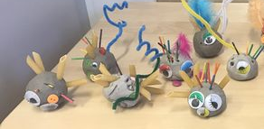  Using clay/hard salt dough make trolls.
Continuous Provision
(enhancements and challenges)
Key Vocab
RE
 | F3- which places are special and why? A special place- at a Church | F3- which places are special and why? A special place- at a Church | F3- which places are special and why? A special place- at a Church | F3- which places are special and why? A special place- at a Church | F3- which places are special and why? A special place- at a Church | F3- which places are special and why? A special place- at a Church
Learning Intention
Direct Teaching
Adult-Led Provision
(enhancements and challenges)
Continuous Provision
(enhancements and challenges)
Key Vocab

