Cycle A- Autumn 2- Sparkle and Shine
Key Texts | Bonfire- Sparks in the sky  Fireworks  Fire safety | Remembrance  The light in the night  Light and dark  Overcoming fears | How to catch a star  Stars | A little blue dot  Info story text – planets  Solar system | My pet star  Caring for a poorly star | Nativity/Christmas
Cultural capital | Bonfire day in school |  |  |  |  | Perlethorpe Nativity trip
Communication and language
Learning Intention | - Ask questions to find out more and to check they understand what has been said to them.  - Articulate their ideas and thoughts in well- formed sentences.  - Connect one idea or action to another using a range of connectives.  - Describe events in some detail.  - Engage in story times.
Direct Teaching | Sparks in the Sky (Fireworks-themed story)  Activity: Firework News Report Role-Play  Description: After reading the story, children take turns role-playing as reporters describing the fireworks display from the story. Others can be "interviewers" asking questions like “What did you see?” or “How did it make you feel?”  Learning Focus:  - Ask questions – Interviewers ask about the event.  - Articulate thoughts – Reporters describe what they “witnessed.”  - Connect ideas – Use connectives: “First…, then…, after that…”  - Describe in detail – Colours, sounds, reactions.  - Story time engagement – Builds on story content and themes. | The Light in the Night by Marie Voigt  Activity: Create Your Own Shadow Story  Description: Children use torches and puppets (or hands) to create their own story using light and shadows, inspired by the book. They then describe what’s happening in their shadow scene.  Learning Focus:  - Ask questions – Encourage children to ask each other about characters: “Who is that? What is it doing?”  - Articulate in sentences – Explain what's happening clearly.  - Use connectives – “Because”, “so”, “and then”, “but”.  - Describe events – What the shadow character is doing, where it goes, what it sees.  - Engage in story time – Builds on story concept of light overcoming fear. | How to Catch a Star by Oliver Jeffers  Activity: Plan a Star-Catching Adventure  Description: Children work in pairs or small groups to plan how they would catch a star. Provide drawing materials for their plans and have them present their ideas.  Learning Focus:  - Ask questions – Children ask each other “How will that work?” or “What happens next?”  - Well-formed sentences – “I would build a rocket because the star is in the sky.”  - Connect ideas – “First I would…, then I’d…, after that…”  - Describe in detail – Their tools, the plan, the challenges.  - Story engagement – Ties directly to the plot and theme. | A Little Blue Dot by Scott Stuart  Activity: Blue Dot Thought Map Discussion  Description: After reading, children create a “thought map” of Earth or a place they love on the planet. In groups, they take turns sharing what makes Earth special and ask each other questions.  Ask questions – “Why do you like that place?” or “What animals live there?”  Articulate ideas – “I think Earth is special because…”  Connect ideas – “I like the ocean because it has fish, and the waves crash.”  Describe in detail – Nature, people, colours, feelings.  Story engagement – Encourages connection to the emotional message of the story. | My Pet Star by Corrinne Averiss  Activity: Pet Star Diary Retell  Description: Children pretend they are the main character and keep a simple “diary” of looking after the star. Each child orally shares one “diary entry” with the class or in small groups.  Learning Focus:  - Ask questions – “What did your star do today?” “Was it happy?”  - Well-formed sentences – “Today, my pet star and I…”  - Use connectives – “Then”, “next”, “after that”, “because”.  - Describe in detail – How the star looked, what they did together, emotions.  - Story engagement – Deepens emotional and narrative connection.
Adult-Led Provision  C and L time.  (enhancements and challenges) | Firework Sound Talk: Children listen to and identify different firework sounds, then copy or sequence them.  Sparkle Story Starters: Children describe fireworks in the sky using words and short sentences to build imaginative language.  Firework Sounds & Actions (Call & Respond): Children match firework sounds with movements and take turns creating their own.  Firework Feely Bag: Children feel textured items in a bag and describe them, linking textures to fireworks.  Bonfire Night Retell: Children sequence pictures of Bonfire Night and retell the story using time connectives. | Night Sky Sounds: Children listen to nighttime sounds and describe or sequence what they hear.  Glow in the Dark Story Starters: Children describe images of glowing lights at night using words, phrases, or sentences.  Shadow and Light Talk: Children explore torch shadows and describe what they see and how it changes.  Light Story Sequence: Children put pictures of a nighttime event in order and retell the story using time connectives.  Firefly Talk: Children pretend to be fireflies, describing where their light goes and what it sees. | Star Description Talk: Children describe a star or shiny object using words or sentences to build descriptive language.  Star Journey Storytelling: Children imagine and talk about how they would catch a star, using phrases or full sentences.  Star Movement Game: Children act out star-themed movements and describe what they are doing.  Star Sequencing: Children sequence pictures of a star-catching adventure and retell the story using time connectives.  Star Conversation: Children pretend a star has landed and take turns asking and answering questions about it. | Describe Our Planet: Children describe the Earth using words or sentences to build descriptive language.  Journey of the Little Blue Dot: Children imagine exploring the little blue dot and talk about where they would go and what they would see.  Little Blue Dot Movement: Children act out the Earth moving through space and describe their movements.  Earth Story Sequencing: Children sequence pictures of an Earth-themed story and retell it using time connectives.  Talking to the Planet: Children pretend the Earth can talk and take turns asking and answering questions about it. | Describe Your Star: Children describe their imaginary pet star using words or sentences to build descriptive language.  Star Storytelling: Children imagine adventures with their pet star and talk about them using phrases or full sentences.  Star Movement Game: Children act out their pet star’s movements and describe what they are doing.  Star Adventure Sequencing: Children sequence pictures of a star adventure and retell the story using time connectives.  Talking to Your Pet Star: Children pretend their pet star can talk and take turns asking and answering questions about it.
Continuous Provision
(enhancements and challenges)
Personal, social and emotional development | - Express their feelings and consider the feelings of others.  - Show resilience and perseverance in the face of challenge.
 | SCARF- Valuing Differences | SCARF- Valuing Differences | SCARF- Valuing Differences | SCARF- Valuing Differences | SCARF- Valuing Differences | SCARF- Valuing Differences
Learning Intention
Direct Teaching | Activity: “Feelings Firework Jar”  What you’ll need:  - Clear plastic jar or a large container  - Tissue paper or colored paper “fireworks” (reds, oranges, purples, etc.)  - Faces/emotion cards (happy, nervous, excited, scared, etc.)  - Labels or sticky notes  How to do it:  - Read the story and discuss how the characters feel watching the fireworks — some may be excited, others scared.  - Introduce the “Feelings Firework Jar.” Children choose a color firework and match it to a feeling.  - They talk about a time they felt that emotion (e.g., “I felt nervous like the girl when I heard a loud bang too”).  - Ask them how they can help someone else who feels scared or overwhelmed.  - Introduce a challenge (e.g., building a tall tower while loud sounds play softly) to help them practice resilience and calming strategies.  Focus: Naming feelings, empathy, building emotional resilience in sensory-rich situations. | Activity: “Bravery Lanterns”  What you’ll need:  - Paper lantern templates or jars  - Tissue paper, glue, battery tea lights  - Emotion cards and a “Resilience Reflection” sheet  How to do it:  - Discuss the boy’s fear of the dark and how the bear helped him feel brave.  - Children decorate their own “bravery lantern” to light up when they feel scared or need courage.  - While making them, ask: “Can you remember a time you were brave like the boy?”  - Read a simple challenge scenario (“Your toy breaks,” “You can’t find your coat”) — discuss how to handle it.  - Encourage children to share how they might help a friend feel safe or brave.  Focus: Expressing fear safely, supporting others emotionally, recognising brave behaviours. | “Reach for the Stars” Obstacle Challenge  What you’ll need:  - Star cut-outs  - Obstacle course materials (cones, tunnels, hoops)  - “Feelings thermometer” or visual scale  How to do it:  - After reading, discuss how the boy felt when he couldn’t catch the star — and how he didn’t give up.  - Children complete a star-themed obstacle course where they "try and catch their own star."  - Before starting, they rate how confident they feel (happy face to unsure face).  - After completing it, they reflect on how they felt before vs. after. Did they feel proud? Tired? Excited?  - Encourage peer encouragement — “How can we cheer on our friends if they feel like giving up?”  Focus: Perseverance, overcoming disappointment, encouraging empathy and mutual support. | Feelings on the Blue Dot  Give each child a small blue circle of card.  Task:  Children draw a face showing how they feel today on their blue dot.  Follow-up:  Place dots on a big Earth poster.  Talk about how everyone’s feelings matter and are all part of our world.  2. Kindness Orbit Game  Children stand in a circle holding a soft “planet” ball.  Task:  Pass the ball around. When they receive it, they say one kind thing they can do to take care of:  the world  a friend  themselves  Example:  “I can help pick up litter.”  “I can share toys.”  “I can listen when someone is speaking.”
Continuous Provision
(enhancements and challenges)
Key Vocab
Physical Development
Learning Intention | - Revise and refine the fundamental movement skills they have already acquired: rolling, hopping, skipping  - Use their core muscle strength to achieve a good posture when sitting at a table or sitting on the floor  - Confidently and safely use a range of large and small apparatus indoors and outside, alone and in a group  - Develop confidence, competence, precision and accuracy when engaging in activities that involve a ball.
Direct Teaching | DRFU  Get Set for PE | DRFU  Get Set for PE | DRFU  Get Set for PE | DRFU  Get Set for PE | DRFU  Get Set for PE | DRFU  Get Set for PE
Adult-Led Provision- fine motor focus  (enhancements and challenges) | 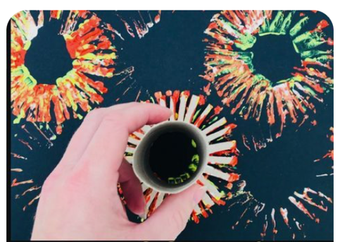 | Model each of the provision activities.
Continuous Provision-fine motor  (enhancements and challenges) | 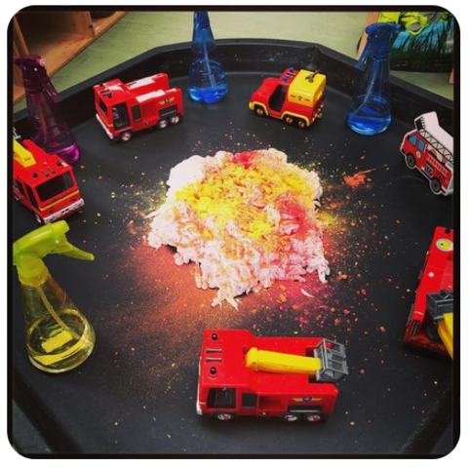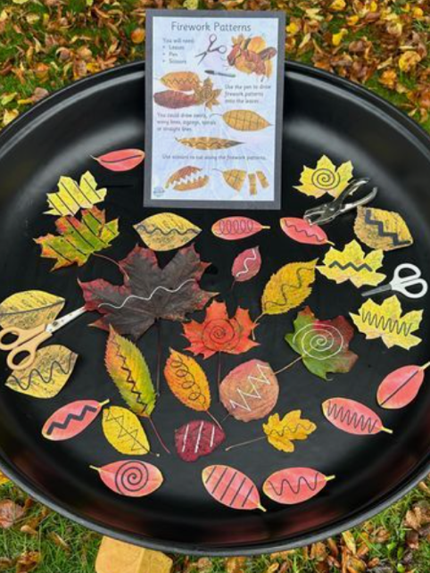 | 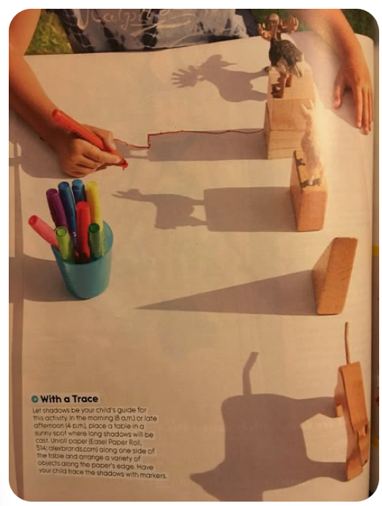 | 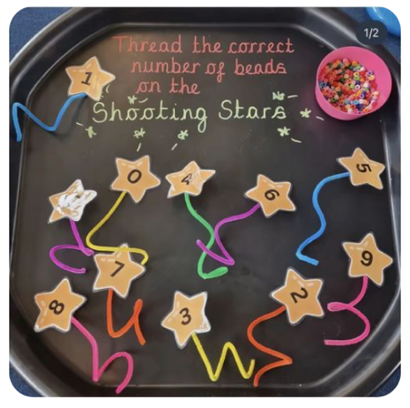 | 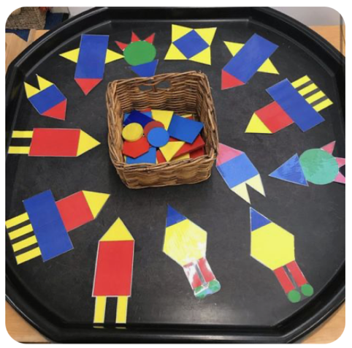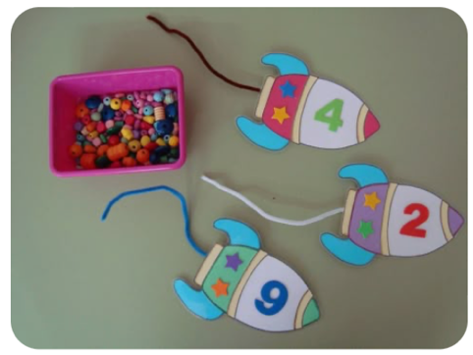 | 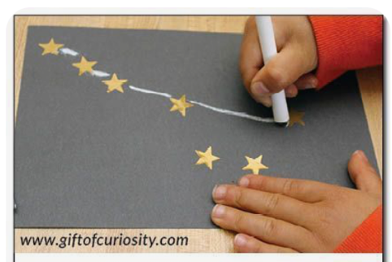
Continuous Provision- gross motor  (enhancements and challenges) | 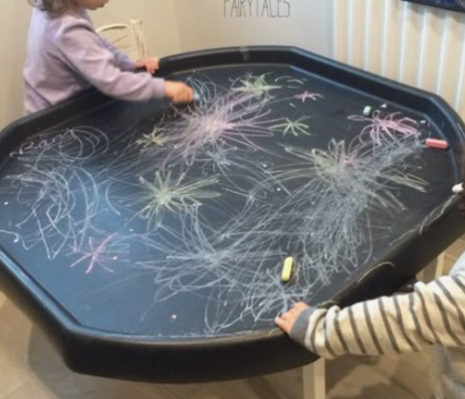 | 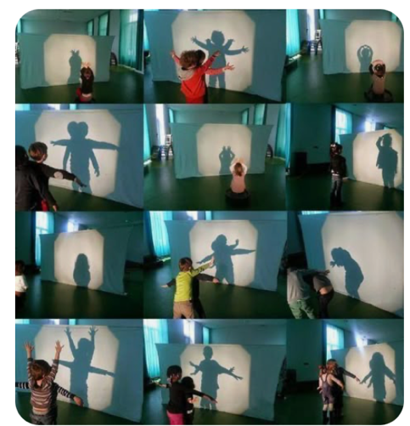 |  | Outdoor build rockets to travel around space.  What does your rocket need?  How many people can travel in your rocket? | Use the outdoor equipment to build your own star constellations.
Key Vocab
Literacy
Learning Intention | - Read individual letters by saying the sounds for them  - Blend sounds into words, so that they can read short words made up of known letter– sound correspondences.  - Re-read these books to build up their confidence in word reading, their fluency and their understanding and enjoyment.  - Spell words by identifying the sounds and then writing the sound with letter/s.
Nursery learning intention | Mark making with different media  Name recognition
Direct Teaching – phonics | l, ll, ss revise and assess P2. | P3- j, v, w, x | P3- y, z, zz, qu | P3- ch, sh, th, ng | P3- ai, ee, igh, oa | P3- oo, ar, or, ur  Week 7- ing ending (2 lessons)
Direct teaching- R writing | A Trip to the Moon  "What do you see on the moon?"  Children write simple words/sentences.  sun, jet, bell, mess, full | Space sounds  “what sounds do you hear in space?”  Children write sound words or nonsense words for alien sounds.  Vix, web, van, | Zoom to the Planet  "Zoom to a new planet! What do you see?"  Children describe things on the new planet.  zip, buzz, quiz, zap | Draw an alien  What is your Alien called?  ‘this is _____’  ‘he/she is ______’ | Rocket Ride  "I can see a…"  Children write a sentence or caption using digraphs.  I see a goat. I see a light. | Letters to santa  Christmas cards
Direct teaching-  N mark making, fine motor, book activity | -Name recognition and writing.  Rocket Name Puzzle – Children piece together a rocket made from the letters in their name. Each letter is a "rocket part".  -My marks mean something, drawing and talking activity.  Draw Your Own Planet – Children create and describe a planet. Adult scribes child's words.  -Initial letter work  S is for Sun – Introduce the sound and letter ‘S’ with sun-themed tracing and sound sorting.  -Guided draw  How to Draw a Rocket – Simple shapes to build a rocket step-by-step.  -retelling the story  Story Sequencing Cards – Use pictures from the story to put events in order and retell it. | -Name recognition and writing.  Name in the Stars – Children trace or decorate their name written in "star shapes" using glitter pens or stickers.  -My marks mean something, drawing and talking activity.  Alien Friend – Draw an alien and talk about where it lives and what it likes.  -Initial letter work  A is for Astronaut/Alien – Sound hunt for ‘A’ items in a sensory tray or classroom.  -Guided draw  Draw the Moon with Craters – Use circles and dabbers or chalk to make a textured moon.  -retelling the story  Role Play the Story – Act out the story using props | -Name recognition and writing.  Astronaut ID Badge – Make a name badge like astronauts wear, with photo and name writing practice.  -My marks mean something, drawing and talking activity.  What’s Inside a Rocket? – Children draw a rocket and imagine what’s inside (bed, food, aliens?). Talk about it.  -Initial letter work  T is for Telescope – Build a paper telescope and look for objects starting with ‘T’.  -Guided draw  Draw a Ringed Planet – Use circle stencils and talk about Saturn's rings.  -retelling the story  Story with Puppets – Use stick puppets to retell key moments. | -Name recognition and writing.  Space Sand Tray – Write names using fingers or tools in black sand with stars (sensory + writing).  -My marks mean something, drawing and talking activity.  Night Sky Picture – Draw stars, moon, comets; talk about what they see in the night sky.  -Initial letter work  P is for planets- cut and stick the planets onto the space background.  -Guided draw  Draw an Alien Face – Focus on symmetry and facial features.  -retelling the story  Make a Story Map – Group creates a giant floor map of the planets- what do you remember from the book? | -Name recognition and writing.  Meteor Trail Names – Children glue letter meteors in order to form their name on a “sky” background.  -My marks mean something, drawing and talking activity.  Space Adventure – Draw themselves in space and tell the story of their adventure.  -Initial letter work  Initial letter from their name- practice letter formation. What things do they know that stat with the same letter as their name? pick things off the big picture (created with all of their names in mind) that start with the same letter as their name letter.  -Guided draw  Draw a Shooting Star – Straight lines and stars with a “whooshing” tail.  -retelling the story  Draw and Talk – Children draw their favourite part and describe what happened.
Continuous Provision  (enhancements and challenges) | Space Sound Hunt  Resources:  - Space-themed sound cards (with Phase 2 phonemes)  - Clipboards and pencils  - Magnet boards or outdoor chalkboards (for marking found sounds)  Set-Up Instructions:  - Place space-themed sound cards around the indoor or outdoor area.  - Ensure some cards are slightly hidden to encourage exploration.  - Provide clipboards and pencils for children to tick off the sounds they find.  Questions to Ask:  - "Can you find the sound that matches this picture?"  - "What sound does this card make?"  - "Can you hear the sound in any of your space words?" | Build the Rocket with Sounds  Resources:  - Large cardboard boxes (for rocket building)  - Space-themed stickers or stamps  - Phase 2 phoneme cards  - Pencils and paper  Set-Up Instructions:  - Construct large cardboard boxes into rocket shapes.  - Provide Phase 2 phoneme cards for children to attach to their rockets using stickers.  - Organise a corner with paper and pencils for children to write space words using the phonemes.  Questions to Ask:  - "What sound do you think goes with this part of your rocket?"  - "Can you tell me a space word using this sound?"  - "How does your rocket take off?" | Space Sound Sorting  Resources:  - Trays or baskets  - Space-themed objects (e.g., toy astronauts, planets)  - Phase 2 sound labels  - Writing materials (whiteboards, pens)  Set-Up Instructions:  - Set out trays or baskets labelled with different Phase 2 sounds.  - Place a selection of space-themed objects that correspond to these sounds.  - Allow children to sort the objects into the correct trays based on their initial sounds.  Questions to Ask:  - "What sound does this astronaut start with?"  - "Can you find something that begins with the same sound as this planet?"  - "Which tray does the rocket belong to?"
Key Vocab
Mathematics
Learning Intention | - Link the number symbol (numeral) with its cardinal number value.  - Count beyond ten.  - Compare numbers  Continue, copy and create repeating patterns.
Direct Teaching  Reception | WRM- step 1  Find 1, 2 and 3 | WRM- step 2  Subitise 1, 2 and 3 | WRM- step 3  Represent 1, 2 and 3 | WRM- step 4  1 more | WRM- step 5  1 less | WRM- step 6  Composition of 1, 2 and 3
Direct Teaching Nursery | Nursery | Block 6 | Subitising 1 – I see 1, 2, 3  Notice images in books | Nursery | Block 6 | Subitising 1 – I see 1, 2, 3  Respond to “I see 1, 2, 3” | Nursery | Block 6 | Subitising 1 – I see 1, 2, 3  Recognise “I see 1, 2, 3” | Nursery | Block 6 | Subitising 1 – I see 1, 2, 3  Copy “I see 1, 2, 3” | Nursery | Block 6 | Subitising 1 – I see 1, 2, 3  Point to 1, 2, 3 | Nursery | Block 6 | Subitising 1 – I see 1, 2, 3  Recognise 1 2 3 in well known tales
Adult-Led Provision  (enhancements and challenges) | 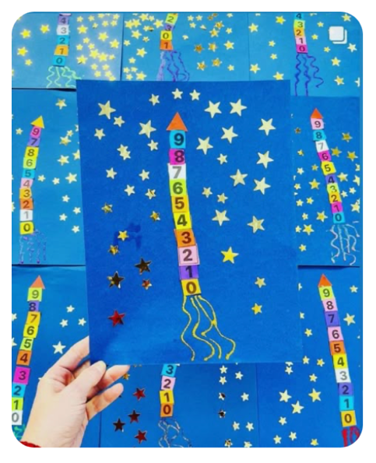 | 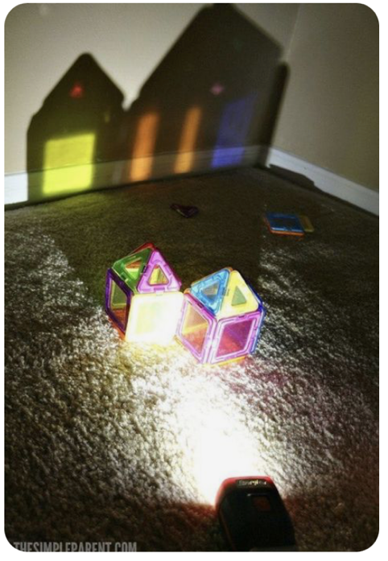 | 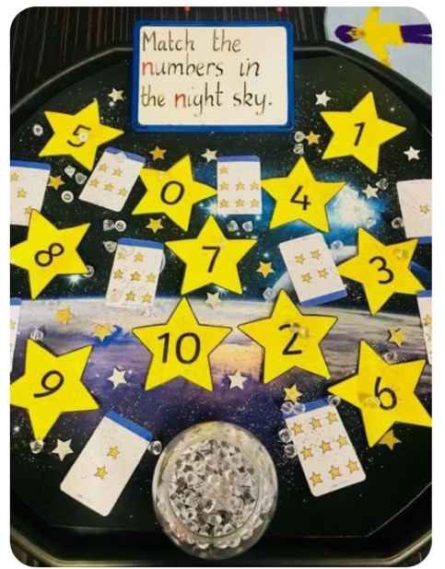
Continuous Provision  (enhancements and challenges) | Maths resources out to explore. | 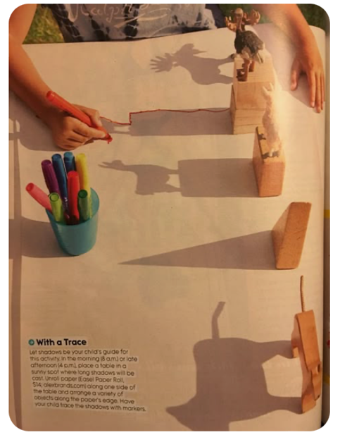 | Number cards and formation activities out. |  | 5 little men in a flying saucer puppets. How many do you strt with?  First now then
Key Vocab
Understanding the World
Learning Intention | - Describe what they see, hear and feel whilst outside  - Explore the natural world around them.  - Recognise some environments that are different from the one in which they live.
Direct Teaching | Firework Sounds and Senses Walk  - Take children outside (or watch a fireworks video safely indoors).  - Encourage them to talk about what they see (bright colours, patterns), hear (bangs, fizzing), and feel (cold air, vibration of sounds).  - Extend with vocabulary: crackle, sparkle, twinkle, loud, bright, dark.  - Discuss safety around fireworks and how celebrations might look different in other countries. | Exploring Light and Dark  - In a darkened room, use torches, lamps, and glow sticks.  - Ask children what they can see and feel as light changes.  - Explore shadows and reflections.  - Compare night and day environments — what changes? What animals might be awake at night? | Compare night and day pictures and talk about sources of light- link to exploring torches last week. | Exploring Our Planet  - Look at photos of Earth from space.  - Discuss what children notice: blue oceans, green land, clouds.  - Talk about how our environment might look different from deserts, rainforests, or cities around the world.  - Introduce simple ideas about caring for the planet (recycling, planting). | Caring for the Star – Feelings and Nature  - Read the story and discuss how the child cares for the star.  - Go outside to “look after” something natural (a plant, a leaf, a stone).  - Encourage children to describe what they see, hear, and feel in the environment while caring for it.  - Talk about how night-time looks and feels different to day.
Adult-Led Provision  (enhancements and challenges) |  | 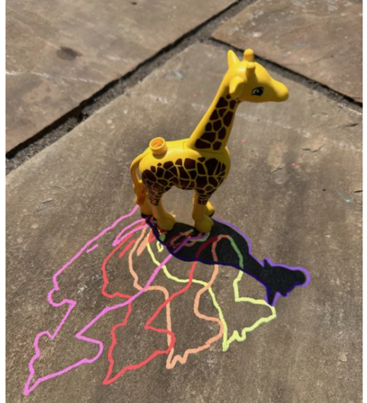 |  | 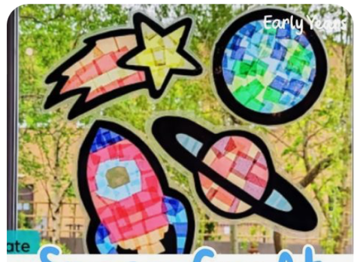
Continuous Provision  (enhancements and challenges) | Small World Fireworks Scene  - Provide black card, glitter, paint, and cotton buds for mark-making “fireworks”.  - Add sound tubes, torches, and coloured scarves to create light and movement in a dark tent or den.  - Encourage describing and exploring sensory experiences of “night-time celebrations.” | 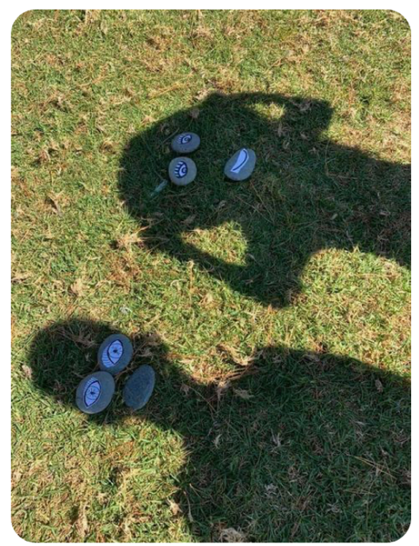 | Space Exploration Role Play  - Create a “space station” or “rocket” in role play.  - Include globes, star maps, and photos of planets.  - Children can “travel” to different environments (space, moon, another country) and talk about what’s different there.
Key Vocab
Expressive Art and Design
Learning Intention | - Listen attentively, move to and talk about music, expressing their feelings and responses. – this strand is ongoing throughout the year  - Return to and build on their previous learning, refining ideas and developing their ability to represent them  - Create collaboratively, sharing ideas, resources and skills  Sing in a group or on their own, increasingly matching the pitch and following the melody
Direct Teaching | 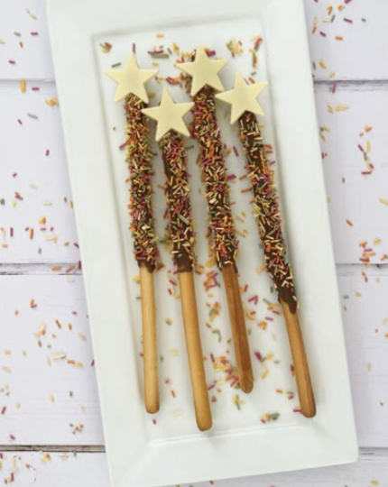 | 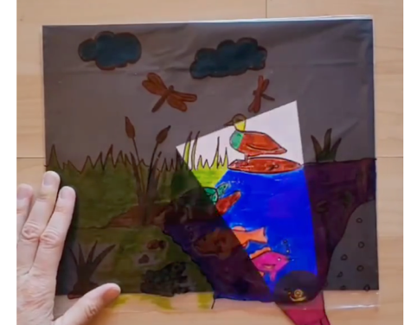 | Singing to the Stars  - Teach a simple song about stars (e.g. Catch a Falling Star or Twinkle, Twinkle with new verses children create).  - Encourage children to sing individually and together, experimenting with pitch (“Can we sing high like the star in the sky?”).  - Add simple instruments (bells, chimes) for children to accompany the song collaboratively.  Use water colours to create colour wash background- cut out a star and take picture of them reaching up to create their own front cover picture. | 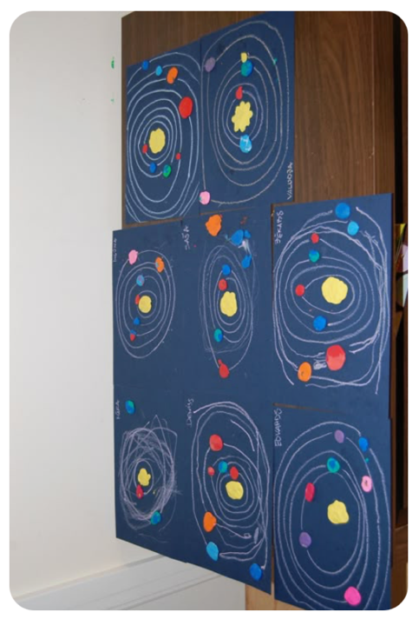 | Make pet stars our of salt dough.  Make the salt dough.  Create stars that they can cut around  Decorate
Adult-Led Provision  (enhancements and challenges) | 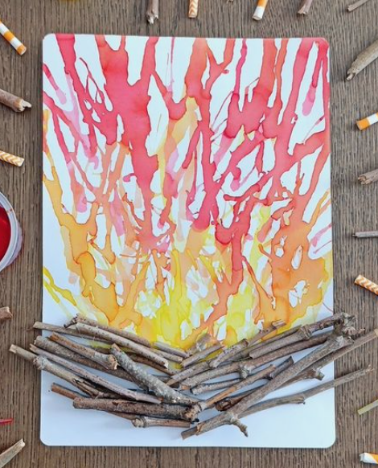
Continuous Provision  (enhancements and challenges) | 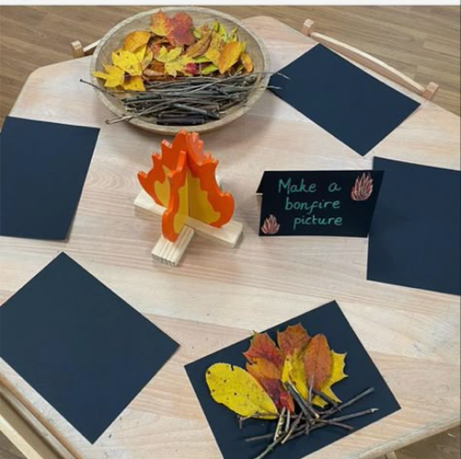 |  | Water colour paints out to colour wash and create childrens favourite scenes from the book. | Planet Art Collaboration  - Provide blue and green paints, sponges, and recycled materials.  - Invite small groups to create a large “Earth” collage.  - Encourage discussion about resource sharing and mixing colours.  - Display the finished collaborative artwork to celebrate teamwork. | Star cutters and sponges on the creative are- make star paintings/collages.
Key Vocab
RE
Learning Intention | F4-What times are special and why? Special times- celebrations.
Direct Teaching | My Special Times  (personal celebrations)  - To understand that everyone has special times.  - What makes a day special?  - How do we celebrate?  Story-  Kipper’s Birthday – Mick Inkpen  - What did Kipper do to celebrate?  - What do you like about birthdays?  - Who do you celebrate with?  Activity-  “My Special Celebration Plate” – draw or collage their favourite celebration.  Assessment Q’s-  Can children talk about a special time and describe how it made them feel? | Guru Nanak Dev Ji’s Birthday  (Sikh) – 5 Nov 2025  - To learn why Sikhs celebrate Guru Nanak’s birthday.  - Why are birthdays special?  - How do people show kindness?  Story-  Guru Nanak and the Missing Money (Sikh story)  - Why do Sikhs remember Guru Nanak?  - What does kindness mean?  Activity-  Kindness Lanterns – decorate paper lanterns with drawings of kind deeds; display as a “Light of Kindness” wall.  Assessment Q’s-  Can children recall why Guru Nanak is special? Do they show understanding of kindness and sharing? | Diwali (Hindu/Sikh)  (celebrated 20 Oct 2025)  - To know Diwali is a festival of lights.  - What do lights make us think of?  Story-  Rama and Sita (Hindu story)  - What happened in the story?  - Why do people light lamps at Diwali?  Activity-  Make a Diya Lamp – decorate a small clay/paper lamp, add flameless tealight.  Assessment Q’s-  Can children explain that Diwali is celebrated with lights and family gatherings? | St Andrew’s Day  (Christian/Cultural – 30 Nov 2025)  - To know that people celebrate special saints.  - Who helps us?  - How do people in Scotland celebrate?  Story-  The Story of St Andrew (Christian story)  - Who was St Andrew?  - How did he help others?  Activity 1 -  Scottish Flag Collage – make a blue and white saltire cross  Activity 2-  Listen to some Scottish music/ watch some Scottish dancing and have a go at dancing.  Assessment Q’s-  Can children talk about who helps them and recall a fact about St Andrew? | Christmas (Christian)  (25 Dec 2025)  - To know Christmas is special for Christians.  - Who was the baby in the story?  - How do people celebrate Christmas?  Story-  The Nativity Story  - Who visited the baby Jesus?  - Why do we give gifts at Christmas?  Activity-  Nativity Scene Collage – create a picture using felt, straw, and paper stars.  Assessment Q’s-  Can children identify key people in the Nativity and recall that Christmas celebrates Jesus’ birth? | Bodhi Day (Buddhist)  (8 Dec 2025)  - To know Bodhi Day celebrates peace and understanding.  - When do you feel calm or peaceful?  Story-  The Buddha and the Hungry Cat (Buddhist story)  - What did the Buddha learn?  - How can we be kind and peaceful?  Activity-  Bodhi Tree of Kindness – create a class tree with paper leaves showing kind acts.  Assessment Q’s-  Do children understand that peace and kindness are special values to celebrate?
Key Vocab | celebration, birthday, family, friends, special, happy | Guru, Sikh, kindness, birthday, light, celebration | Diwali, diya, light, dark, Rama, Sita | saint, Scotland, help, cross, flag, celebration | Christmas, Jesus, Mary, Joseph, star, gift, Christian | Buddha, Bodhi, tree, peace, calm, kindness

