

Foundation Stage Information Book

Welcome to Everton’s Foundation Stage Unit

We hope that you feel part of our school community and that you will become involved in all aspects of school life.

We hope to provide the best start for your little ones. We encourage the children to share and be aware of other individuals’ needs within the group. We create an orderly and kind atmosphere in which the children can cope with their feelings.

Do talk to us if there’s anything you don’t understand or your child is unhappy about – we will do our best to help.


Who’s who in Foundation stage?

Miss Oakley- Early Years Lead and Reception Teacher.

Miss Oakley’s favourite story is ‘Oi Frog!’ by Kes Gray. She loves reading, keeping active and being creative.
Miss Oakley has a dog called Tilly. Tilly loves lots of fuss, playing with a tennis ball and going on nice long walks.



Mrs Coe- Early Years Teaching Assistant

Mrs Coe’s favourite stories are ‘The Gruffalo’ and ‘The Snail and the Whale’ by Julia Donaldson. She loves sports and learning in our outside area.
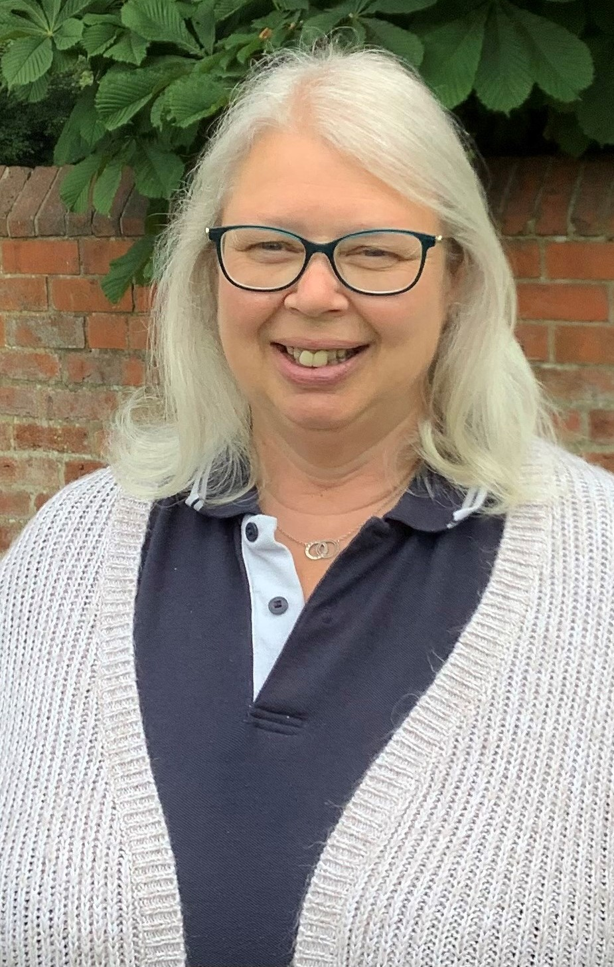
Mrs Coe has lots of animals at her house, she has goats, sheep, chickens, ducks and four dogs called Alfie, Todd, Willow and Yara.
Mrs Coe is usually with us on a Thursday and a Friday.

Mrs Fisher- Early Years Teaching Assistant

Mrs Fisher loves any book by Julia Donaldson, her favourite is ‘Room on the Broom’. She is our RE expert and loves arts and crafts.
Mrs Fisher has a dog called Archie, Archie loves playing catch with his ball.
Mrs Fisher is usually with us on a Monday, Tuesday and Wednesday.
Daily Session Times:

Reception 8:45 am – 3:15 pm

Morning Nursery 8:45 am – 11:45 am
Afternoon Nursery 12:15pm – 3:15 pm

You might be aware that the government currently funds 15 hours of nursery education for every child (this equates to 5 morning or afternoon sessions each week). The government also funds families for an additional 15 hours where either both parents or the sole parent in a single parent family is working at least 16 hours per week and not earning in excess of £100,000 per year. Please check online at https://childcare-support.tax.service.gov.uk to identify whether you are eligible.

For children of nursery age, we provide the following chargeable activities which are in addition to the funded hours which your child is entitled to (15 or 30 hours of funding from the government):

Activities | Charge
Additional nursery session (3 hours) | £14.10
‘Lunch club option A’ – a 30 minute cover between the two 3 hour nursery sessions each day. | £2.35 (plus the cost of a school meal if this is chosen)
‘Lunch club option B’ – an additional hour after the morning session, so children are collected at 12:45. | £4.70 (plus the cost of a school meal if this is chosen)
Nursery charges (additional sessions and lunch club) will be charged via Parentmail.

Before and After School Clubs
Nursery and Reception children are very welcome at breakfast club (from 7:45am) or after school (fun) club. Pick-up times for fun club can be booked until 4pm, 4:30pm or 5pm. Bookings can be made by contacting Miss Oakley on Class Dojo or by contacting the school office. Charges will be invoiced monthly by Parentmail - please see charges overleaf:

Breakfast Club | £3.50
After School Club | £3.50 until 4pm and then £2.50 for each half-hour (or part half-hour) until 5pm.

Uniform and Equipment

At Everton Primary School our uniform consists of:

- Navy blue jumper or cardigan
- Navy blue or white polo shirt/white collared shirt (‘Everton’ tie can be worn with a collared shirt)
- Grey trousers, shorts, skirt or pinafore dress
- Navy blue striped or checked dress
- Black shoes

If your child attends on a Wednesday or Friday morning we have PE sessions so please send your child into school in their PE kit. PE kit consists of navy or black bottoms, navy blue or white top and trainers.
For safety reasons, we ask you not to send your child to school wearing jewellery.

Please ensure all clothing and personal items are named so that we can easily find lost and misplaced items.

Other items your child will need:

- Water bottle
- A bag for taking home any letters, work and reading books.
- A change of clothes in case of any accidents- if we do change your child into school spares we would appreciate it if these are washed and returned as quickly as possible.

Book bags and school uniform (including PE kit) can be purchased from Marks & Spencer (tel. 0844 544 7972 or mandsyourschooluniform.com).

A snack and milk are provided.

Lunch time
All of the children in Early Years eat together regardless of whether they have packed lunches or school dinners, they all eat together in the school hall. At morning register, your child will be asked whether they are having a school dinner or a packed lunch, we would appreciate it if you would let your little ones know what they are having in the morning to save staff going through bags to check for packed lunches.

Teaching, learning and assessment.
In Early Years, we focus on a weekly text that all our learning is based upon. Each half term the overall theme for these texts changes as well.

Every day is different in Early Years, having said this we follow a timetable to ensure consistency and coverage of our Early Years Curriculum. We start every day the same by writing our names, singing our days of the week song and weather song and sharing the story of the week. We split into Nursery and Reception for phonics, maths and literacy and join back together as an Early Years unit at outside break time, lunch time and story time.

Assessment is informal and on-going in both Nursery and Reception. In Nursery, the children have mark making books to record name writing, mark making activities and maths activities. In Reception, children have separate literacy and maths books to record weekly adult-led tasks- these are a record of the progress that the children have made over their time in Reception and also a way of getting ready for being in Class 1 where all work is recorded in books.

Alongside these books, we will share pictures and videos of the activities and learning that children do in class on our home-school communication tool Class Dojo.

Phonics and Reading
Phonics in Nursery is focused around listening and attention skills. The children will have daily phonics sessions with an adult focusing on the different aspects of phase 1 phonics. We will send home picture books with no words or text, these are just as important as books that contain text. They help your child to talk about the story and get them ready to use the picture clues in books which will eventually give them one of many strategies to find out what text says and means. Encourage your child to use the illustrations to tell the story. What can they tell you about the characters? How are they feeling? How do they know? What might happen next?

At Everton Primary School, we use the phonics scheme Unlocking Letters and Sounds which was validated by the Department for Education in December 2021. We begin teaching phase 2 phonics in the first few weeks of term 1 in Reception and children make rapid progress in their reading journey. Children begin to learn the main sounds heard in the English Language and how they can be represented, as well as learning ‘Common Exception’ words for Phases 2, 3 and 4. They use these sounds to read and write simple words, captions and sentences. Children leave Reception being able to apply the phonemes taught within Phase 2, 3 and 4.

We promote a phonics first approach in guided reading and with the reading books that we send home. Books are matched to each child’s current phonic knowledge so that every child can experience real success in their reading. In early stages of reading, we primarily use books from Ransom Reading Stars and Collins Big Cat to ensure complete fidelity to the Unlocking Letters and Sounds progression that we follow.

You can help increase your child’s comprehension skills and enjoyment of books by reading with your child and talking about what is happening in the story. Questions include: What might happen next? Do they like the story? Would they have preferred a different ending? How were the characters feeling? What did the characters say?

Collecting Children at the end of the session.
Please let us know if other adults will be collecting your child from school. It is also helpful to let your child know when possible. Please record a password on the pupil admission form that accompanies this booklet; we will use the password to identify the adult collecting your child. We will not hand over a child to a person we cannot identify so to avoid any issues or inconvenience please let us know in advance.
Absence
Please telephone and let us know if your child is unable to attend Nursery or Reception. In line with guidance from the Health Protection Agency, we request that children remain at home for 48 hours after sickness and/or diarrhoea.

Parking outside school
We kindly ask that you do not park opposite the zig zag lines outside school when dropping off or collecting your child from school. This is because it can make it dangerous to cross the road and causes traffic congestion. We also ask that you consider the school’s neighbours and do not sit or walk on their walls and gardens.

School Contact Details

Everton Primary School,
Chapel Lane,
Everton,
Doncaster,
DN10 5BJ

Tel: 01777 817350

Web site: www.evertonprimary.co.uk
E-mail: office@everton.notts.sch.uk

We also use Class Dojo as a home school communication tool throughout school. Class Dojo is a great way for staff to share photos, videos, information and events with adults at home. It also has a great messenger service so that we are able to communicate easily with home. Messages can be sent directly and privately to staff members if you have any concerns, worries or need to pass on a message about your child. You will get a letter inviting you to join your child’s class page in their first week.

