Transition & Information Guide 2024/2025
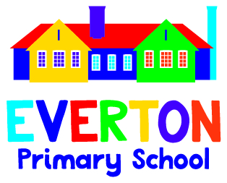
Everyone. Everyday. Everlasting.
https://www.evertonprimary.co.uk

Welcome to Class 1

Class 1 is a mixed aged class of Year 1 and Year 2 children.
Year 1 is such an important time for many reasons. Our main priority for the them is to transition into their new class and over to the National Curriculum. The Y1 Phonics screening will take place at the beginning of June and will assess the phonics taught in Y1 to date.
Initially we will focus on building the skills taught in Reception and continuing your child’s journey of learning through exploration and play through classroom provision.
Year 2 is a continuation of the National Curriculum and development of new skills and knowledge. The children will become more independent and have opportunities to explore and investigate in science, computing and topic work.
In September our first topic will be ‘Paws, claws and whiskers’ with an art and Science focus. The children will be able to bring photos of their pets and maybe even a visitor or 2!
Showing our EverTen is something we promote daily in Class 1. Each day, we will choose a ‘Star of the Day’. Our Star will be rewarded with a small prize.
A typical day in Class 1 looks a little bit like this (some days may be a little different!).
8:45: Welcome
9:00: Morning activity and reading
9:15: Phonics
9.40: Maths
10:20 Break
10:45: Guided reading
11:15: English
12:00: Lunch
1:00 - 2.30 Afternoon learning would link to our curriculum so it will be lessons such as Science, History, Geography, PE, RE, PSHCE, Music, DT or Art.
2.30 - 2.40 Milk and fruit
2.50 Whole school or class assembly

You can find more information regarding our class’s curriculum through our class’s Curriculum Maps on our school website: https://www.evertonprimary.co.uk/curriculum-maps/
Please note that these are in the process of being updated.
Key events that should be happening during this academic year include (Dates will be confirmed nearer the time):
- Harvest Festival
- Nativity performance
- Christmas Craft afternoon
- Christingle
- Christmas Fayre
- Easter Celebration
- Sports Day
- Summer Fayre
- Class trip

There will be many other dates, which we will update you on throughout the academic year.
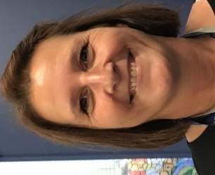
Staff:
Mrs Oldbury is the Class Teacher
Monday to Wednesday.

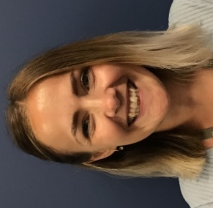
Mrs Milburn is the Class Teacher
Wednesday to Friday.
Mrs M is currently on maternity leave but will return in the Spring term 2025
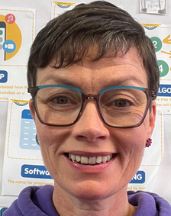
Mrs Clarke is class teacher
Thursday and Friday
until Mrs Milburn returns

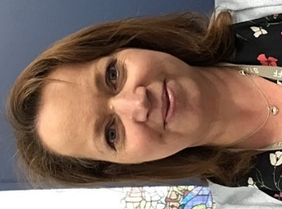
Ms Strickland is the Teaching Assistant Monday to Friday

PE:
PE is taught by Doncaster Rovers on a Wednesday as we are a Club Doncaster Foundation School and by Mrs Clarke/Mrs Milburn on a Friday. All pupils will need to come into school in their PE kits on those days every week.

A reminder that PE kit is plain navy shorts or jogging bottoms, plain white or navy polo shirt or t-shirt, plain navy jogging top or sweatshirt (there should be no logos on these items other than the Everton Primary School logo) and trainers.
For more details regarding PE kit or school uniform then please refer to the school website: https://www.evertonprimary.co.uk/uniform/

Homework:
Our main homework focus area is reading.
Reading: All children should be reading 5 times a week ideally. This will give them a range of skills that they can use across all curriculum subjects and in their writing.
In Year 1 we would like you to spend the time exploring your child’s school reading book that is matched to their current phonic stage.
In Year 2 once the children have completed their phonics journey and levelled books associated with each stage, they will progress on to a library book that is based on their Accelerated reading level. You will be informed once we are ready for them to move on to this.
Please don’t limit reading to just the school books, writing is everywhere and it’s great to read a range of sources and genres.
Please record a date and simple comment in their reading records so we know when your child has read. Reading books and diaries need to be in school every day and books will be changed as required (generally on a weekly basis- we encourage children rereading their books to develop fluency).
Topic/ writing: To support your topic learning, we will set challenges throughout each half term. These will be communicated via Dojo.
Maths: We encourage children to access online maths learning games (Numbots and Hit the Button). We will give more information once the children have transitioned and settled into the class.
Please feel free to Dojo us if you would like to discuss how you can support your child at home about their learning. A strong partnership between home and school will help your child best.

Trips/Visitors:
In Class 1, we like to invite special visitors in to support our topics. If you know of any visitors that might like to come into our school and add to our children’s educational experiences and cultural capital, then please let Mr Green or the class staff know.
Once the trips have been confirmed we will let you know when they are and the cost involved.
Snack time:
Each day the children can purchase a snack during their break time. Snacks include: a slice of toast, a toasted teacake, or a piece of fruit (25p each).
If you wish for your child to purchase any snack food then you will need to put a credit balance on your child’s ‘Morning Break Snacks’ account on ParentMail.
In addition to morning snack, all children in the FSU and Class 1 will be offered a fruit snack in an afternoon.
If your child would like to continue receiving milk this needs to be purchased separately via the cool milk website; https://www.coolmilk.com/. All children entitled to free school meals will receive milk (this does not include universal free school meals).

Parent helpers:
If anyone is available to volunteer in the class, on trips, or walks around the village then please let us know.
We are really looking forward to continuing your school journey with you as you make the next step in your education. We have lots of exciting things planned for us to do that we can’t wait to share with you. If anyone would like to chat to us about anything, we can be contacted via Class Dojo.

