Transition & Information Guide 2024/2025

Everyone. Everyday. Everlasting.
https://www.evertonprimary.co.uk

Welcome to Class 2
(Year 3)
Welcome to Class 2!
Class 2 is a mixed aged class of Year 3 and Year 4 children.
Year 3 is such an important time for many reasons. Our main priority for the Year 3 children is to feel settled and confident as they enter Key Stage 2. Children will start to use their prior knowledge to further extend their knowledge in all curriculum areas. Within maths, Year 3 is an important year to begin to gain confidence with times-table facts.
Initially we will focus on a short topic ‘Heroes and Villains’ and our class text will be ‘Matilda’ by Roald Dahl. Through this book, we will be following the story of Matilda, who is a very intelligent young girl. With inspiration from this book, we will be writing our own letter. In Maths, we will be exploring place value of number to 1,000. The children will also be introduced to a new curriculum area: French.
You can find more information regarding our class’ Curriculum through our class’ Curriculum Maps on our school website: https://www.evertonprimary.co.uk/curriculum-maps/
Key events that should be happening during this academic year include (Dates will be confirmed nearer the time):
- Christmas Craft afternoon
- Y4 Statutory Times-Tables Check
- Christmas Church Service
- Easter Church Service
- Y3/4 Residential
- Christingle
- PTA events throughout the year
- Sports Day

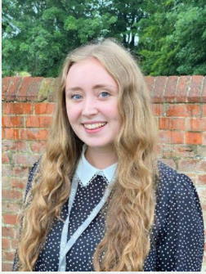
Staff:
Miss Spencer is the Class Teacher.

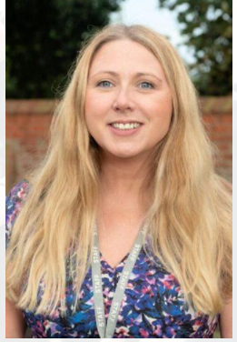
Mrs Evers is the Class Teaching Assistant.

PE:
PE will be on Wednesday and Fridays. All pupils will need to come into school in their PE kits on those days every week.

A reminder that PE kit is plain navy shorts or jogging bottoms, plain white or navy polo shirt or t-shirt, plain navy jogging top or sweatshirt (there should be no logos on these items other than the Everton Primary School logo) and trainers.

For more details regarding PE kit or school uniform then please refer to the school website: https://www.evertonprimary.co.uk/uniform/

Swimming:
In Class 2 we will have access to Retford Leisure Centre’s swimming pool for a block placement at some point in the academic year. We will inform you of exact dates and timings as soon as they are confirmed.
We understand the anxieties that some children may have about swimming and we will spend time in class discussing and sharing the routines for this. Alongside the swimming instructors, the children will also be supported by Miss Spencer and Mrs Evers. Please note that swimming is part of the curriculum so all must attend.
If you would be able to volunteer to help with swimming then this would be greatly appreciated, and please could you let Miss Spencer know.
Homework:
In Year 3 the expectations regarding homework at Everton Primary School are as follows:
Reading: As per the rest of the school, Year 3 should be reading at least 3 times a week although we do encourage 5 reads a week. Reading books need to be in school every day and the children will be able to take a quiz on Accelerated Reader once they have finished a book.
Spellings: Spelling lists will be given out at the start of each half-term and they will be assessed every Wednesday. Spellings are linked to the key word lists in the National Curriculum.
Maths/English: Homework works on a two-weekly routine shown below:
- Week 1= An activity-based homework, e.g. a worksheet, a project.
- Week 2= App-based homework, e.g. completing tasks on TTRS, exploring LetterJoin.
Please feel free to Dojo us if you’d like to discuss how you can support your child at home with regards to their learning. A strong partnership between home and school will help your child best.

Trips/Visitors:
We are hoping to have several visitors/visits in Class 2 including:
- Y3/4 Kingswood Residential
- Visit to the Bassetlaw Museum.

If you know of any visitors that might like to come into our school and add to our children’s educational experiences and cultural capital, then please let Mr Green or Miss Spencer know.

Snack time:
Each day the children can purchase a snack during their break time. Snacks include: a slice of toast, a toasted teacake or a piece of fruit (25p each).
If you wish for your child to purchase any snack food then you will need to put a credit balance on your child’s ‘Morning Break Snacks’ account on ParentMail.

If your child would like to receive milk this needs to be purchased separately via the cool milk website https://www.coolmilk.com/.

Parent helpers:
If anyone is available to volunteer in the class, on trips, or walks around the village then please let us know.
We are really looking forward to continuing your school journey with you as you make the next step in your education. We have lots of exciting things planned for us to do that we can’t wait to share with you. If anyone would like to chat to us about anything we can be contacted via Class Dojo (https://www.classdojo.com/).

