Transition & Information Guide 2024/2025

Everyone. Everyday. Everlasting.
https://www.evertonprimary.co.uk

Welcome to Class 3
(Year 5)
Welcome to Class 3!
Class 3 is a mixed aged class with both Year 5 and Year 6 children.
The move from Year 4 to Year 5 is an exciting time as you move into what we call Upper Key Stage 2. Moving into Year 5 means you are only 2 years away from secondary school so this is the perfect opportunity to begin to develop independence skills further. In Class 3, we will work on these skills so you can become more independent. We think this is a perfect time for you to begin to take more responsibility, which includes: ensuring you have picked up your home learning and spellings, are wearing PE Kits on the correct day and packing your bag so you have all the correct equipment.
Throughout your time in Class 3, you will notice teamwork is crucial and we expect you to fully throw yourself into all learning opportunities and enjoy every minute! This means contributing in lessons, taking pride in your written work, showing our EverTen and remaining focused during learning time. Each day, Miss Scott and I will be looking out for children doing this and if it’s you, you will be rewarded ‘Star of the Day’.
A typical day in Class 3 looks a little bit like this (some days may be different!):
8:45: Morning Challenges, which are on the board
9:05: Reading
9:45: English
10:30: Break
10:45: Maths
11:45: Handwriting or Spelling
12:00: Lunch
1:00: Take 5
Afternoon learning would link to our curriculum so it will be lessons such as Science, History, Geography, PE, RE, PSHCE, Music, French, DT or Art.
If we have been working really hard, we sometimes have an afternoon break (what a treat!)
You can find more information regarding our class’ curriculum through our class’ Curriculum Maps on our school website: https://www.evertonprimary.co.uk/curriculum-maps/
Key events that are happening during this academic year include:
Autumn 1: Hagg Farm Residential Field Trip
World War 2 visit (venue and dates to be confirmed)
Café Europe – Our DT project where we cook for parents (Village Hall and date to be confirmed)
Easter Service (Church date to be confirmed)
Coal Mining Museum (Date to be confirmed)

There will be many other dates, which I will update you on throughout the academic year.

Staff:

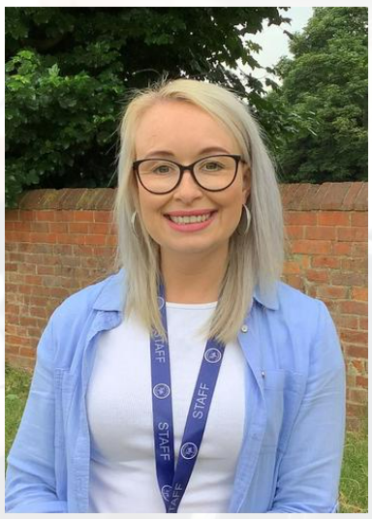
Mrs Lewins is Class 3’s teacher.

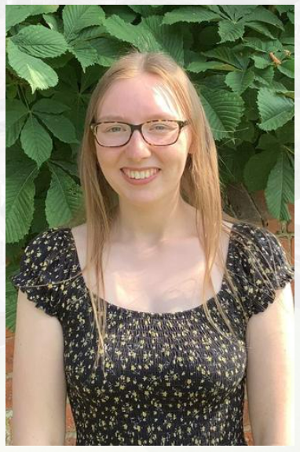
Miss Scott is Class 3’s Teaching Assistant.

PE:
PE is taught by Doncaster Rovers on a Wednesday as we are a Club Doncaster Foundation School. Our other PE session will be taught by Mrs Lewins or Miss Scott and this will be on a Friday. All pupils will need to come into school in their PE kits on those days every week.

A reminder that PE kit is plain navy shorts or jogging bottoms, plain white or navy polo shirt or t-shirt, plain navy jogging top or sweatshirt (there should be no logos on these items other than the Everton Primary School logo) and trainers.

For more details regarding PE kit or school uniform then please refer to the school website: https://www.evertonprimary.co.uk/uniform/

Homework:
In Year 5, the expectations regarding home-learning at Everton Primary School are as follows:
Reading: As per the rest of the school, you should be reading at least 3 times per week although we do encourage 5 reads a week. Most pupils are now on free choice reading using the ZPD scales from our STAR reading programme. The record of reading is kept by ensuring that you quiz every book you read. Miss Scott will record reading and children will be rewarded with 3 Dojos for more than 3 reads per week.
Spellings: Spellings are linked to the key word lists in the National Curriculum. We will focus on one spelling rule each week and spellings will be linked to those rules. Each Monday, children will be given the list of spellings, which they can practise at home; we will also work on spellings during spelling lessons on a Wednesday, Thursday and Friday. Every Friday, we will do a mini spelling assessment so we can see if we need to provide any further support on the focus spelling rule that week. Children will be rewarded 2 Dojos each week if we feel they have worked hard on the spellings that week.
Maths: Maths home learning will be sent out every Monday and can be returned the following Monday. Maths home learning consists of 5 arithmetic questions and 1 reasoning question to be completed on a daily basis. The home learning is split into daily activities. Spending five minutes (revisiting and reviewing) each night, rather than doing it in one go, helps the children with their ‘over-learning’ and long-term memory retention of each skill. Every Wednesday, Miss Scott will go through the previous week’s home learning so any misconceptions can be addressed.

Snack time:
Each day the children can purchase a snack during their break time. Snacks include: a slice of toast, a toasted teacake or a piece of fruit (25p each).
If you wish for your child to purchase any snack food, then you will need to put a credit balance on your child’s ‘Morning Break Snacks’ account on ParentMail.
Parent helpers:
If anyone is available to volunteer in the class (listening to readers etc), helping on visits, or walks around the village, then please let us know. Your help will always be much appreciated.
Please feel free to Dojo, chat (at the start or end of day) or call us if you’d like to discuss anything; a strong partnership between home and school is so important to us and it will help your child do and be their very best!

